INDICATORS OF SUSTAINABLE AGRICULTURE:
A SCOPING ANALYSIS

Installment 8 of “Creating a Sustainable Food Future”

A working paper for the World Resources Report: 2013-14

AUTHOR

Katie Reytar (Associate, WRI).
Contact: kreytar@wri.org

ACKNOWLEDGMENTS

The authors would like to acknowledge the following individuals for their critical reviews: Lauretta Burke (WRI), Francis Gassert (WRI), Craig Hanson (WRI), Norbert Henninger (WRI), Mike McGahuey (USAID), Lars Christian Oxe (Danish Ministry of Foreign Affairs), Stephen Russell (WRI), Johann Scharr (WRI), Tim Searchinger (WRI), Richard Waite (WRI), Robert Winterbottom (WRI).

We thank the following for their guidance: Hanne Carus (Danish Ministry of Foreign Affairs) and Mogens Laumand Christensen (DANIDA and WRI).
We thank Emily Schabacker for style editing and Mary Paden for copyediting and proofreading. In addition, we thank Hyacinth Billings, and Jen Lockard for publication layout and design.

For this working paper, WRI is indebted to the generous financial support of the Danish Ministry of Foreign Affairs.

This working paper represents the views of the authors alone. It does not necessarily represent the views of the World Resources Report’s funders.

TABLE OF CONTENTS
SUMMARY 3
I. INDICATORS AND A SUSTAINABLE FOOD FUTURE 5
II. THE LANDSCAPE OF EXISTING INDICATORS OF THE ENVIRONMENTAL SUSTAINABILITY OF AGRICULTURE 7
III. PARAMETERS FOR SELECTING CANDIDATE INDICATORS 9
Thematic areas 9
Stage in causal chain 11
Screening criteria 12
IV. Candidate environmental sustainability indicators 14
The short-list indicators and metrics 14
Some caveats 17
Integrating the indicators into an index 17
V. PROPOSED NEXT STEPS 18
Activities 19
End products 20
Who to engage 20
Concluding thoughts 20
REFERENCES 21
ENDNOTES 22

SUMMARY

Quantifiable indicators of the environmental sustainability of agriculture are an important tool for helping move the world toward a sustainable food future. Indicators enable policymakers, farmers, businesses, and civil society to better understand current conditions, identify trends, set targets, monitor progress, and compare performance between regions and countries. But what indicators are most appropriate?

To address this question, the World Resources Institute (WRI) conducted a scoping exercise to identify a preliminary list of candidate indicators at the nexus of agriculture and environment. This working paper describes the methods and results of this analysis.

First, we identified, analyzed, and profiled the landscape of existing indicators, indices, and datasets regarding the environmental sustainability of agriculture. Second, we selected the most relevant “thematic areas” for environmental sustainability in agriculture. These areas are water, climate change, land conversion, soil health, and pollution.

Third, we identified the generic stages of the “causal chain” of action that an index or indicators can represent or seek to influence. These stages are public policy, farmer practice, and biophysical performance.

Fourth, we selected seven screening criteria against which to assess candidate indicators. These screening criteria are availability of data, accuracy of data, consistency in how data is gathered, frequency of data, data’s proximity to reality, relevancy of data, and ability for data to differentiate between countries.

Fifth, we identified a “long list” of candidate indicators of environmental sustainability in agriculture for each of the five thematic areas and for each of the three stages in the causal chain. Indicators came from the landscape analysis as well as WRI input. We then evaluated each of these possible indicators against the seven screening criteria. Those that fared best became the “short list” of candidate indicators (Table 1).

Sixth, we explored options for how to integrate the indicators into an overall index on the environmental sustainability of agriculture. Finally, we proposed a set of next step activities for creating and establishing indicators of the environmental sustainability of agriculture.

Table 1. Summary of first draft candidate environmental sustainability indicators at the country level (unit of measure)

 |  |  |  |  |  | Pollution
 | Water | Climate change |  | Land conversion | Soil health | Nutrients | Pesticides
Policy | Existence of policies requiring measurement of agricultural water withdrawals* (Yes/No) | Existence of policies promoting low-GHG agricultural development*  (Yes/No) |  | Existence of policies limiting conversion of natural ecosystems to agriculture*  (Yes/No) | Existence of policies promoting agricultural soil conservation practices*  (Yes/No) | Existence of policies promoting nutrient management practices* (Yes/No) | Degree to which the country has limited or outlawed the most toxic pesticides according to the Stockholm Convention (22 point scale)
Practice | Share of cropland area with efficient irrigation practices in place* (percent) | Share of farm area with agricultural GHG emissions management practices* (percent) |  | n/a | (1) Share of arable land under soil conservation practices* (percent)  and/or  (2) Share of cropland under conservation agriculture (e.g., crop rotations, reduced tillage, cover crops) (percent) | Share of agricultural land practicing nutrient management* (percent) | Share of cropland under integrated pest management (percent)
Performance | (1) Crop production per drop of water (tonnes of crop produced per m³ water per year)  in combination with  (2) Water stress ratio (water demand in m³ / water supply in m³) | Food production per unit of GHG emissions* (tonnes of food produced per year per tonne of CO₂-equivalent) |  | Conversion of natural land (e.g., forests, wetlands) to agricultural land (crop and pasture)* (hectares of converted land per year) | (1) Share of agricultural land affected by soil erosion* (percent)  and/or  (2) Percent change in net primary productivity (NPP) across agricultural land* (percent)  and/or  (3) Soil organic matter (carbon) content (tonnes C per hectare) | (1) Nutrient input balances on agricultural land (i.e., difference between N & P inputs and outputs)* (kg N & P per hectare of agricultural land)  and/or  (2) Fertilizer applied per unit of arable land (tonnes of nutrients per hectare of arable land) | Pesticide use per unit of cropland (tonnes of active ingredient applied per hectare)

INDICATORS AND A SUSTAINABLE FOOD FUTURE

The World Resources Report’s Creating a Sustainable Food Future: Interim Findings describes how the world faces a great balancing act of three needs (Box 1). It needs to close a 6,500 trillion kcal per year gap between the food available in 2006 and that required in 2050―a 69 percent increase from 2006 levels―to adequately feed the planet. It needs agriculture to contribute to economic and social development. And it needs agriculture to reduce its impact on climate, water, and ecosystems.

The working paper series and interim findings of Creating a Sustainable Food Future explore a menu of solutions that could combine to meet these three needs. While each of the installments to date has profiled one menu item, this installment focuses on how to measure progress towards achieving a sustainable food future. In particular, it focuses on possible indicators of the environmental sustainability of agriculture. Such indicators would communicate to policymakers, farmers, the private sector, and civil society the degree to which these menu items in aggregate are having an impact in moving agriculture on to a sustainable trajectory.

We originally conducted this analysis of potential indicators in order to inform the design of a proposed Agricultural Transformation Index (ATI). Supported by the governments of Denmark and the United States and other organizations, the ATI would be designed to guide public and private sector decision-making by showing “in which countries is it good to be a farmer or conduct agribusiness” and where policy initiatives are needed to promote inclusive and sustainable growth in the agricultural sector. Suggested components of the ATI were agribusiness, policy-induced distortions, public investments, agricultural knowledge and technology systems, smallholder productivity, and environmental sustainability. Our task was to evaluate candidate indicators for the environmental sustainability in agriculture component.

Per request of those supporting the ATI development process, we set several boundaries for the scoping exercise. First, it covered only land-based agriculture, and not wild fisheries or aquaculture, since the scope of the ATI was land-based agriculture. Second, it considered only the environmental dimension of sustainability and not the social or economic dimensions, since the latter may be captured in other indexes being considered for development. Third, its geographic scale was at the national level, since the purpose of the proposed ATI was to publish national indicators and indices that, among other applications, would compare performance between countries and thereby stimulate a “race to the top.”

At the time of publication, the status of overall ATI development is unclear. Nonetheless, our research provided insights that could inform a standalone set of indicators and index on the environmental sustainability of agriculture, as well as contribute to other efforts that involve indicators regarding agriculture such as the World Bank Group’s “Benchmarking the Business of Agriculture” project and efforts to establish post-2015 development goals.

This working paper summarizes the results of this scoping exercise. It begins by describing the results of a landscape survey of existing indicators, indices, and datasets that address environmental sustainability of agriculture. It continues by proposing which thematic areas indicators should cover and what screening criteria to use. It then articulates a short list of candidate indicators that emerge based on application of the criteria against a long list of options. It concludes by proposing next steps for creating indicators of environmental sustainability of agriculture.
Box 1. The World Resources Report

How can the world adequately feed more than 9 billion people by 2050 in a manner that advances economic development and reduces pressure on the environment? This is one of the paramount questions the world faces over the next four decades.

Answering it requires a “great balancing act” of three needs―each of which must be simultaneously met. First, the world needs to close the gap between the food available today and that needed by 2050. Second, the world needs agriculture to contribute to inclusive economic and social development. Third, the world needs to reduce agriculture’s impact on the environment. The forthcoming World Resources Report, Creating a Sustainable Food Future, seeks to answer this question by proposing a menu of solutions that can achieve the great balancing act.

Since the 1980s, the World Resources Report has provided decision-makers from government, business, and civil society with analyses and insights on major issues at the nexus of development and the environment. For more information about the World Resources Report and to access previous installments and editions, visit www.worldresourcesreport.org.

THE LANDSCAPE OF EXISTING INDICATORS OF THE ENVIRONMENTAL SUSTAINABILITY OF AGRICULTURE

When developing indicators of the environmental sustainability of agriculture, it is important to first understand the existing landscape of indicators, indices, and datasets at the nexus of agriculture and the environment. One need not reinvent the proverbial wheel. Important questions to address include: What indices and indicators about the environmental sustainability of agriculture already exist? To what degree are they sufficient? What appropriate datasets already exist? What can be learned and leveraged from these existing indices, indicators, and datasets?

To address these and related questions, we identified, reviewed, and synthesized the landscape of existing indicators, indices, and datasets that appear related to some degree to the environmental sustainability of agriculture. Via discussion with WRI experts, consultation with other experts in the field of sustainable agriculture, and an extensive literature review, we identified more than two dozen candidate sources of agri-environmental indices, indicators, and/or data. We may not have identified every candidate in the world, but we do believe our scan uncovered a significant share of them. We screened them for relevance and, on further examination, several sources were relevant in name only, not in content. Table 2 summarizes those sources that passed the first quick screen. These sources include indices, reports, and datasets.

We then profiled and summarized each of these indices, reports, and datasets in an Excel Workbook available at www.wri.org/food/indicators entitled “Landscape of Existing Agri-Environmental Indicators.” Each profile includes lead developer or compiler, objective, most recent year, frequency of update, geographic coverage, and web URL. For each indicator provided in these indices and reports, we profiled the indicator theme, indicator, metric, unit of measure, scale, and data source.

These profiles yield several insights, including:
- No systematic global or near-global index of environmental sustainability of agriculture appears to currently exist.
- The most relevant existing global index, Yale’s Environmental Performance Index, includes agriculture as a small component of a much larger global assessment of national-level environmental performance within numerous economic sectors.
- The most thematically relevant report, OECD’s Environmental Performance of Agriculture in OECD Countries Since 1990, is geographically limited to only 30 OECD member countries and does not aggregate environmental indicators into a single index, but rather reports on each indicator separately. Nonetheless, the OECD indicators can provide inspiration for the types of indicators to aspire to as data collection becomes better and more consistent globally.
- The most common themes of existing indicators at the nexus of environment and agriculture are water use by agriculture, agriculture policies (especially agriculture subsidies), and greenhouse gas emissions from agriculture. Table 3 lists these and other common indicator themes and provides examples of specific indicators within each theme.
- Many of the indicators used by the indices and reports profiled in the Excel workbook are either irrelevant or only tangentially related to the environmental sustainability of agriculture.

Table 2. Summary of sources reviewed in evaluating the landscape of existing environmental indicators (not exhaustive)

Type | Title | Lead organization
Index | Environmental Performance Index (EPI) 2012 | Yale Center for Environmental Law & Policy; Columbia University
Index | Environmental Vulnerability Index (EVI) 2004 | South Pacific Applied Geoscience Commission (SOPAC); UNEP
Index | Global Adaptation Index (GaIn) 2012 | Global Adaptation Institute
Index | Hunger Reduction Commitment Index (HRCI) 2011 | Institute of Development Studies
Index | Rice Bowl Index 2011 | Frontier Strategy Group/Syngenta
Index | Rule of Law Index (2012 - 2013) | World Justice Project
Report | Africa Capacity Indicators Report 2012 | African Capacity Building Foundation
Report | Agricultural Policy: Monitoring and Evaluation (2012); Agricultural Policies in Emerging Economies: Monitoring and Evaluation (2009) | Organisation for Economic Cooperation and Development (OECD)
Report | Agricultural Science & Technology Indicators (ASTI) | International Food Policy Research Institute (IFPRI)
Report | Environmental and Socioeconomic Indicators for Measuring Outcomes of On-Farm Agricultural Production in the United States 2012 | Field to Market, The Keystone Alliance for Sustainable Agriculture, The Keystone Center
Report | Integration of environment into EU agriculture policy - the IRENA indicator-based assessment report 2006 | European Environment Agency
Report | Environmental Performance of Agriculture in OECD Countries Since 1990 | Organisation for Economic Cooperation and Development (OECD)
Report | Indicators from the global and sub-global Millennium Ecosystem Assessments: An analysis and next steps | World Resources Institute
Report | National water footprint accounts: The green, blue and grey water footprint of production and consumption 2011 | Water Footprint Network; UNESCO-IHE Institute for Water Education
Report | Resource Revolution: Meeting the world's energy, materials, food, and water needs 2011 | McKinsey Global Institute
Data | Aqueduct Water Risk Atlas | World Resources Institute
Data | ECOLEX Global Database of Environmental Law | FAO, IUCN and UNEP
Data | FAO AQUASTAT (Information system on water and agriculture) | Food and Agriculture Organization of the United Nations (FAO)
Data | FAOSTAT (Information system on hunger, food, and agriculture) | Food and Agriculture Organization of the United Nations (FAO)
Data | Global Eutrophic and Hypoxic Coastal Systems | World Resources Institute
Data | Soil property maps of Africa at 1 km resolution | Africa Soil Information Service (AfSIS)/ ISRIC World Soil Information/ World Agroforestry Centre (ICRAF)
Data | UN Information Portal on Multilateral Environmental Agreements (InforMEA) | UNEP
Data | Data Access Centre for Ozone Depleting Substances | UNEP Ozone Secretariat
Data | UNEP Environmental Data Explorer | UNEP
Data | World Bank World Development Indicators - Agriculture and Rural Development | World Bank
Table 3. Most common indicator themes among existing indices, reports, and datasets reviewed

Indicator theme | Number of occurrences | Indicator (example)
Water use | 35 | Total water use for agriculture production
Agricultural policy related to government support | 18 | Agricultural subsidies
Climate change | 13 | Greenhouse gas emissions from agricultural sources
Agricultural production | 11 | Crop yield
Agricultural inputs | 10 | Fertilizer use
Land use | 10 | Area of agricultural land
Environmental policy | 10 | Participation in UNFCCC treaties
Environmental degradation | 7 | Area of degraded/barren lands
Ecosystem biodiversity | 6 | Wild species in agricultural lands
Water quality | 6 | Number of dead (hypoxic) zones
Agricultural Research & Development | 5 | Public agricultural research expenditures
Ecosystem management | 4 | Area of terrestrial reserves
Agricultural policy related to the environment | 4 | Pesticide regulations

PARAMETERS FOR SELECTING CANDIDATE INDICATORS

To lay the foundation for identifying candidate indicators on environmental sustainability of agriculture, we pursued a step-by-step process. First, we identified the most relevant “thematic areas” for indicators, that is, what we deemed are the most significant aspects or topics at the nexus of the environment and agriculture that candidate indicators should target. Next, we identified the generic types of activity that an index or indicators can represent and seek to influence, what we call the “causal chain.” Then we selected a suite of screening criteria against which to assess candidate indicators. For each of these activities, we leveraged the landscape assessment and internal WRI expertise.

Thematic areas
Agriculture impacts a variety of natural resources and environmental phenomena. Some of these impacts, however, are more important for overall human well-being than others and some comprise a significant share of overall human impact on the environment. Based upon our assessment of these impacts, we propose that any environmental sustainability index reflect at least five thematic areas. The first three are those that are the focus of environmental concern in Creating a Sustainable Food Future: Interim Findings, namely:
- Water. Agriculture accounts for 70 percent of the world’s freshwater withdrawals and for 80 to 90 percent of its freshwater consumption.
- Climate change. In 2010, about 13 percent of global anthropogenic greenhouse gas emissions came from agricultural production, most notably from ruminants, manure, fertilizers, rice, and on-farm energy use. Land use change, the majority of which is triggered by agriculture, contributed another 11 percent of global greenhouse gas emissions (Figure 1).

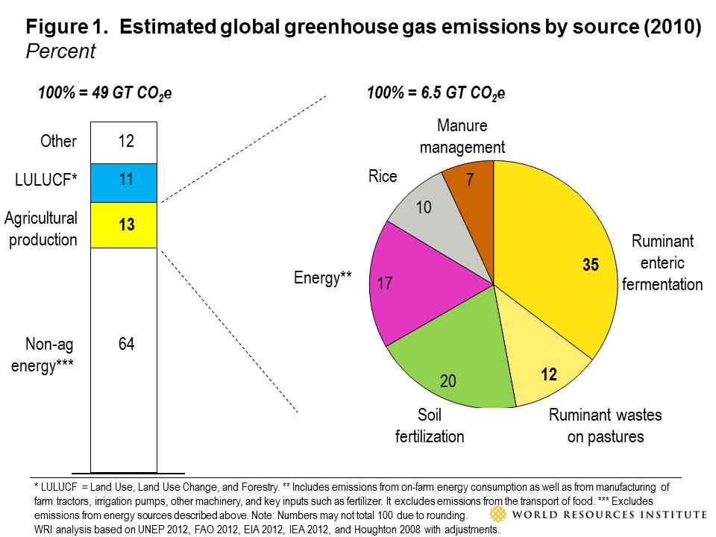
- Land conversion (terrestrial ecosystems). Since the dawn of the first agricultural revolution 8,000-10,000 years ago, growing crops and raising livestock have been the primary cause of loss and degradation of natural ecosystems. Today, 37 percent of the planet’s landmass outside of Antarctica is already dedicated to growing food; 12 percent is in croplands and 25 percent is in grazing lands. The majority of current land-use change in the world results from agriculture, in the form of the conversion of forests, wetlands, and grasslands into farms and grazing pastures. For instance, agriculture was responsible for roughly 80 percent of tropical deforestation between 2000 and 2010. Land use change can be a proxy for biodiversity, as well, since habitat loss is the most significant cause of biodiversity loss in the world.

The other two proposed thematic areas have cross-cutting importance for human well-being, food security, climate, water, and ecosystems, namely:
- Soil health. Soil plays a key role in maintaining a balanced ecosystem and producing quality agricultural products. However, soil erosion and degradation continue to threaten the availability and productivity of land for growing food. Annually, about 10 million hectares of cropland are abandoned due to soil erosion and related loss of productivity. It is estimated that soil is being lost at a rate 10 to 40 times faster than the rate of soil replenishment, which poses a threat to long-term human food security. Furthermore, in many places, soil’s capacity to retain nutrients, retain moisture, and maintain a healthy pH is declining.
- Pollution (nutrients, pesticides). Inputs of nutrients, particularly nitrogen and phosphorus, are essential for growing crops and supporting healthy crop yields. Maintaining balanced nutrient levels in the soil is critical to both production and environmental health: a deficiency in nutrients can reduce soil fertility and limit production, while surplus nutrients can lead to ecosystem degradation when nutrients are lost to water or air. Impacts of excess nutrients on the environment include eutrophication of surface waters, impairment of groundwater, and emissions of harmful greenhouse gases, particularly nitrous oxide. Agricultural nutrient pollution primarily stems from over-application or poorly-timed application of fertilizers to cropland and waste from livestock. Furthermore, chemical pesticides―while beneficial for preventing crop losses to insects and other pests―can have detrimental effects on human health, wildlife, water quality, and other environmental factors depending on the toxicity of the constituent chemicals and application conditions.

Four of these five thematic areas align with international conventions. Climate change is covered in the UN Framework Convention on Climate Change (UNFCCC); land conversion has links to the UNFCCC and the Convention on Biological Diversity (CBD); soil health has links to the UN Convention to Combat Desertification (UNCCD); and pesticide pollution has links to the Stockholm Convention on Persistent Organic Pollutants and the Rotterdam Convention.

Stage in causal chain
Indices and indicators seek to reflect and ultimately influence multiple types of behavior. With regard to agriculture, they can reflect policies, practices, and performance, a combination that constitutes a causal chain of behavior. More specifically, government policies can influence farmer practices which in turn can determine on-the-ground performance or conditions. For example, a regulation (“policy”) that requires a farmer to measure the water she withdraws for crop irrigation can create an incentive for her to implement conservation irrigation techniques (“practice”) which, in turn, can affect the “crop per drop” or the water use efficiency on her farm (“performance”).

Ideally, indicators on environmental sustainability should reflect all three parts of the causal chain in order to be comprehensive. Policy indicators reflect the policies that could create the right enabling conditions or incentives for sustainable agriculture. Practice indicators reflect the on-farm practices that realize sustainable agriculture. Performance indicators reflect the desired, on-the-ground, biophysical state of the world.

Of course, this causal chain represents a simplification of a reality that has complex interactions at political, social, and economic levels. Policy is a bundle of steps itself. For instance, policies create regulations or incentives, the effectiveness of which is a function in part of enforcement. Practices are not always triggered by policies in a linear fashion, just as performance is not a linear result of practices. Nonetheless, this three-part structure can provide a useful framework for the types of indicators to select or develop.

There are some generic trade-offs between indicators along this causal chain (Figure 2). Performance indicators tend to measure real world conditions and, therefore, arguably reflect more accurately what is happening “on the ground” than policy indicators. Policies, on the other hand, do not always yield on-the-ground results if there is poor design or enforcement. On the other hand, policy indicators are typically easier and less resource-intensive to assess and measure than performance indicators. Furthermore, policy indicators are actionable for governments, whereas performance indicators are more difficult for governments to act upon.

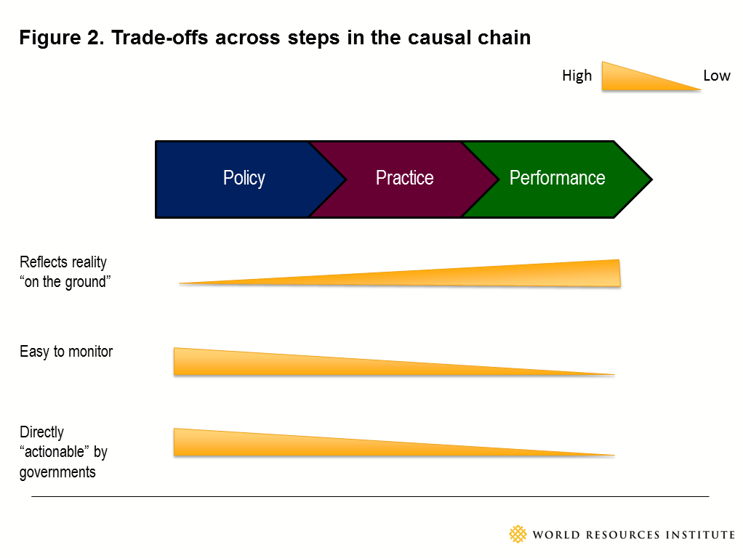

Screening criteria
After identifying thematic areas and steps in the causal chain, we then determined the criteria or methodological features against which to assess the suitability of an environmental sustainability indicator. We used the following criteria to assess suitability:
- Available: Are the data underlying the indicator currently available for most countries?
- Accurate: Are the data underlying the indicator accurate, reliable, and representative of reality?
- Consistent: Are the data collection methods consistent and the data comparable across all countries?
- Frequent: Are the data regularly collected or updated such that they are relatively current?
- Proximate: Is the indicator or its data indicative of the environmental sustainability of agriculture with respect to the theme being considered? In other words, is it a good “proxy” for reality?
- Relevant: Is the indicator or its data highly pertinent to policy decisions involving environmental sustainability of agriculture?
- Differentiating: Is the indicator or its data specific enough to result in variability between countries and thereby to differentiate between actors?

To assess how well a candidate indicator meets one of these criteria, we developed a simple three-part scale of “high, medium, low” or “green, yellow, red”, respectively. Table 4 summarizes the definitions of high, medium, and low for each of these criteria.

Table 4. Screening criteria and rating

Criterion | High | Medium | Low
Available | Data are currently available for most countries globally. | Data are currently available for some countries, but collection would be required for other countries. | Data are not currently available anywhere and would require new collection.
Accurate | Data are accurate, reliable, and representative of reality. | The accuracy, reliability, and/or representativeness of the data are unclear. | The existing data are inaccurate, unreliable, and/or unrepresentative of reality.
Consistent | Data collection methods are consistent across countries and the data are comparable across all countries. | Data collection methods may not be consistent and/or data may not be comparable across all countries. | Data collection methods are inconsistent and/or data is not comparable across countries (i.e., variation in time scales, baselines, definitions).
Frequent | Data are collected and/or updated on a regular basis and at a frequency such that the data are relatively current. | Data are collected and/or updated on an irregular basis, but might be more regularly updated in the future. | The data are currently not planned to be collected or updated again (i.e., they come from a one-time study).
Proximate | Data are indicative of the environmental sustainability of agriculture with respect to the theme being considered. They are a good “proxy”. | Data are somewhat indicative of the environmental sustainability of agriculture with respect to the theme being considered, but they are not the ideal proxy. | Data are not indicative of the environmental sustainability of agriculture with respect to the theme being considered.
Relevant | Data are highly pertinent to policy decisions involving the environmental sustainability of agriculture. | Data could be relevant to policy decisions involving the environmental sustainability of agriculture, depending on the context. | Data are too generic or too far removed from on-the-ground performance or practice and thus are not relevant to policy decisions.
Differentiating | Data are specific enough and produce sufficient variability amongst countries to differentiate between actors. | Data could be elaborated to ensure that they are specific enough to produce variability at the national level to differentiate between actors. | Data do not produce enough variability amongst countries to adequately differentiate between actors.

Candidate environmental sustainability indicators

Once the parameters had been selected, we proceeded to identify candidate indicators of environmental sustainability in agriculture. We began by generating a list of possible indicators for each of the five thematic areas and for each of the three categories in the causal chain. To generate this initial list, we took indicators identified in the landscape analysis as well as created indicators based on WRI team expertise. We then evaluated each of these possible indicators against the seven screening criteria. Those that fared best against the criteria became the initial “short list” of candidate indicators.

The short-list indicators and metrics
The Excel Workbook entitled “Evaluation of Candidate Indicators of Environmental Sustainability of Agriculture”, available at www.wri.org/food/indicators, entitled presents the list of possible indicators. Each worksheet is dedicated to a thematic area (e.g., water, climate, soil health). Each worksheet is organized by category in the causal chain (i.e., policy, practice, performance) on one dimension and by selection criteria (e.g., available, accurate, consistent) on the other. Each possible indicator is evaluated against these criteria, accompanied by comments providing further clarification on the indicator. Those selected to be on the “short list” of candidate indicators are highlighted in the Excel Workbook and are summarized in Table 5 below.
Water
For the water theme, the candidate indicators are those that best reflect agricultural pressure on water resource use. The candidate indicators for this theme include:
- For policy, existence of policies requiring measurement of agricultural water withdrawals;
- For practice, share of cropland with efficient irrigation practices implemented; and
- For performance, agricultural water productivity (i.e., crop production per drop) combined with a water-stress ratio.
The water-stress ratio is used to distinguish between water-rich and water-poor countries. For example, a low crop-per-drop performance may not signal a problem in countries with low water stress (i.e., where water is abundant). As water use is one of the most studied and documented aspects of agri -environmental sustainability, the candidate data for this theme are largely already available at a global level through sources such as FAO, although our recommendations also include ways of improving existing datasets.

Climate change
For the climate change theme, the candidate indicators are intended to capture the impact of agriculture on greenhouse gas (GHG) emissions and therefore on climate change. Candidate indicators include:
- For policy, the existence of low-GHG agricultural development policies or emissions management incentives;
- For practice, the share of farms with GHG emissions management practices in place; and
- For performance, the total GHG emissions from food production per ton of food produced.

Given that GHG emissions are connected to many other agricultural activities covered in other themes, such as land-use conversion and soil erosion, capturing environmental sustainability in other themes could serve as a proxy for climate change, and thus the indicators presented here measure specific activities related to emissions and can reinforce the indicators in other themes.

Land conversion
This theme is intended to capture indicators of agricultural pressure on land conversion, which in turn can have implications for biodiversity, climate change, and other environmental issues. The candidate indicators for the land conversion theme include:
- For policy, existence of policies limiting conversion of natural ecosystems to agriculture; and
- For performance, area of natural land conversion to or from agriculture.

No practice indicators were included on the short list, as there appear to be no applicable indicators of land conversion practices that would not already be captured by the performance indicator.

Soil health
This theme covers indicators of the impact of agriculture on soil health and productivity, including:
- For policy, the existence of policies promoting soil conservation practices;
- For practice, share of farmland under soil conservation practices and/or share of farmland under conservation agriculture; and
- For performance, area of agricultural land affected by soil erosion, and/or percent change in net primary productivity (NPP) across agricultural land, and/or soil organic matter (carbon) content.

Nutrients
This theme represents indicators of environmental degradation caused by agricultural nutrient inputs, including:
- For policy, the existence of policies or incentives to promote nutrient management practices;
- For practice, the share of agricultural land practicing nutrient management; and
- For performance, nutrient input balances (i.e., ratio of inputs to outputs) and/or fertilizer applied per unit of arable land.

Pesticides
This theme covers indicators of the environmental impact of agricultural pesticide use, including:
- For policy, the degree to which the country has regulated the most toxic pesticides (according to the Stockholm Convention);
- For practice, the share of cropland under integrated pest management; and
- For performance, the extent of pesticide use per unit of cultivated land.

Table 5. Summary of first draft candidate environmental sustainability indicators at the country level (unit of measure)

 |  |  |  |  |  | Pollution
 | Water | Climate change |  | Land conversion | Soil health | Nutrients | Pesticides
Policy | Existence of policies requiring measurement of agricultural water withdrawals* (Yes/No) | Existence of policies promoting low-GHG agricultural development*  (Yes/No) |  | Existence of policies limiting conversion of natural ecosystems to agriculture*  (Yes/No) | Existence of policies promoting agricultural soil conservation practices*  (Yes/No) | Existence of policies promoting nutrient management practices* (Yes/No) | Degree to which the country has limited or outlawed the most toxic pesticides according to the Stockholm Convention (22 point scale)
Practice | Share of cropland area with efficient irrigation practices in place* (percent) | Share of farm area with agricultural GHG emissions management practices* (percent) |  | n/a | (1) Share of arable land under soil conservation practices* (percent)  and/or  (2) Share of cropland under conservation agriculture (e.g., crop rotations, reduced tillage, cover crops) (percent) | Share of agricultural land practicing nutrient management* (percent) | Share of cropland under integrated pest management (percent)
Performance | (1) Crop production per drop of water (tonnes of crop produced per m³ water per year)  in combination with  (2) Water stress ratio (water demand in m³ / water supply in m³) | Food production per unit of GHG emissions* (tonnes of food produced per year per tonne of CO₂-equivalent) |  | Conversion of natural land (e.g., forests, wetlands) to agricultural land (crop and pasture)* (hectares of converted land per year) | (1) Share of agricultural land affected by soil erosion* (percent)  and/or  (2) Percent change in net primary productivity (NPP) across agricultural land* (percent)  (3) Soil organic matter (carbon) content (tonnes C per hectare) | (1) Nutrient input balances on agricultural land (i.e., difference between N & P inputs and outputs)* (kg N & P per hectare of agricultural land)  and/or  (2) Fertilizer applied per unit of arable land (tonnes of nutrients per hectare of arable land) | Pesticide use per unit of cropland (tonnes of active ingredient applied per hectare)

Some caveats
A few caveats are important to note. First, given that this working paper summarizes a scoping exercise, the candidate list represents those indicators that we deem most suitable for further research and vetting―particularly with regard to data availability, accuracy, and frequency.

Second, we did not restrict selection of candidate indicators to only those for which data is already available in all countries. While faring poorly on the data availability criterion, some of the suggested candidate indicators would be very accurate, proximate, relevant, and differentiating. We include them on the short list as a signal that the international community should consider generating and collecting data for these indicators.

Third, in the Excel Workbook, we provide some preliminary ideas for how to collect missing data. For instance, remote sensing― for detecting soil degradation or land conversion to agriculture―is quickly advancing in terms of resolution, coverage, and processing costs and could increase in importance as a data source on the environmental performance of agriculture. Furthermore, many environmental policy indicators simply have not yet been compiled at a multi-national level. In short, we recommend some indicators with an eye toward their future potential.

Integrating the indicators into an index
After finalizing the suite of indicators, a subsequent step is to integrate the indicators into a single index, capable of standing and being reported on its own. Integration involves weighting and aggregating the constituent components of the index. The constituents are assigned weights based on statistical criteria or expert judgment. Then they are aggregated in either a linear or non-linear fashion. Options with respect to weighting and aggregating include (Figure 3):
Weighting
- Equal weighting: This approach gives all components equal significance in the index.
- Adjusted weights based on statistical correlation: This approach uses a correlation coefficient to test components in order to either (1) choose for inclusion only those components that have a low degree of correlation and assign equal weights, or (2) adjust the weights of components according to their degree of correlation (e.g., give less weight to correlated indicators). This approach avoids double-counting or biasing the index in favor of statistically similar components.
- Differential weighting based on expert judgment: This approach involves convening a group of experts to assign weights to components based on their judgment of which components are more or less important in reflecting policy priorities or other objectives of the index.

Aggregating
- Arithmetic average: This linear approach sums all components and divides them according to the size of the collection. This approach values each component in equal proportion. The result is that a high score for one component can compensate for a proportionally lower score for another component.
- Geometric average: This non-linear approach uses the product of the components to the n^{th} root (where n is the size of the collection).This approach rewards a high score for each component and penalizes a low score more than a linear aggregation approach. The result is that it is much more difficult for a high score in one component to offset or compensate for a low score in another component.
- Assigning a “knock-out” threshold: In this approach, a minimum threshold value is set that specific components must be met if the set of components is to be aggregated. Failure of one component to meet its threshold prevents the aggregation from occurring. This approach could apply to the integration of the environmental sustainability index into a larger agricultural index. For example, if a country fails to meet a minimum threshold for environmental sustainability, it would not receive an overall index “score” or a very poor score, no matter how well the country performs on the other indices.

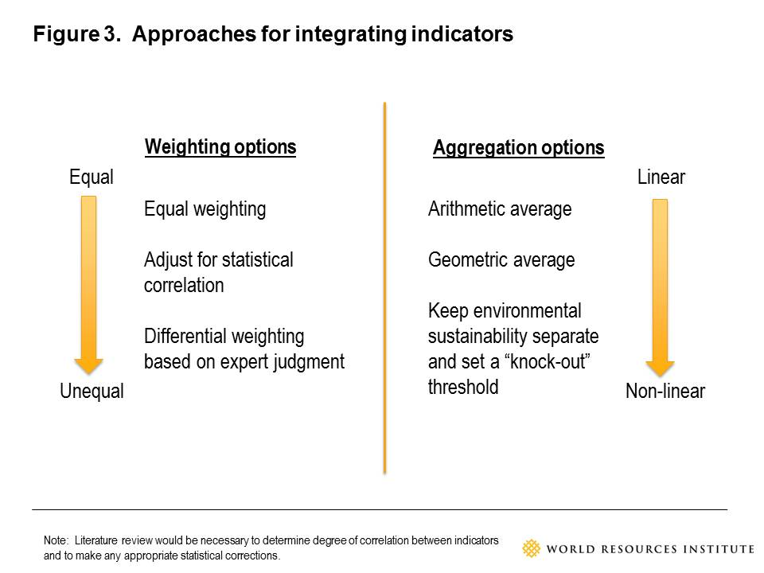

When integrating indicators into an overall index, a few points are important to keep in mind. First, no one integration approach for designing an index is considered statistically or scientifically superior to another and all represent value judgments. Second, the approach selected depends largely on the index’s intended purpose. Third, avoid having constituent indicators that overlap or cover the same issue, otherwise there will be “double counting” of some indicators in the aggregate index. Fourth, avoid having constituent indicators that are the opposite of each other, otherwise there will be “zeroing out” of components of the aggregate index.

PROPOSED NEXT STEPS

Designing indicators and an index for the environmental sustainability of agriculture will require new work. It is not possible to simply adopt or repackage an existing index or indicators and end up with something that is sufficiently robust. While data exist for some indicators, there are still remaining information gaps that hinder designing a suite of indicators and associated index that sufficiently covers the range of important thematic areas. Closing these gaps will require a collaboration of partners with a variety of expertise ranging from data gatherers and statisticians to agriculture and sustainability experts.

Given the wide variation in data availability, a pragmatic process for developing the indicators and an index could be to produce a version 1.0 that is later replaced by a version 2.0. Version 1.0 would be based upon indicators for which data are readily available, including existing global datasets from FAO and the World Bank, and thus would take less time to complete and serve as a “first cut” set of indicators and index. They might not be comprehensive or ideal, but they would be a start. Version 2.0 would build upon this by adding or substituting in novel indicators that require substantial, new data collection.

The following provides an overview of activities, end products, and who to engage for creating an environmental sustainability of agriculture index and suite of indicators.

Activities
Primary activities include:
- Refine the purpose, scope, target audience of an environmental sustainability of agriculture index.
- Confirm or refine the parameters for selecting candidate indicators (i.e., thematic areas, causal chain, screening criteria) identified in this scoping exercise.
- Applying these parameters, refine the selection of optimal candidate indicators, identifying those that could be prepared relatively quickly for a version 1.0 and those that are ideal but will take time to develop or collect the requisite data and thus could be part of an version 2.0.
- For the candidate indicators to be included in version 2.0, contact and engage existing and prospective providers of the requisite data. Develop a “data gathering” (for existing data) and “data generation” (for missing data) strategy, and create a “mandate” or demand signal for missing requisite data to be collected
The following activities apply to both versions 1.0 and 2.0:
- Road test the candidate indicators and data collection in at least a dozen countries representing different degrees of agricultural development, to determine feasibility of gathering sufficient data and to refine indicator designs.
- Start collecting data for a full set of countries based on insights from the road tests.
- Refine the weighting and aggregation method for combining indicators into an index. Engage statisticians and other experts on creating composite indices to evaluate and refine the methodology for combining indicators. Where necessary, conduct multivariate analysis to determine the suitability of the underlying datasets, adjust datasets to account for outliers, and perform sensitivity analysis of the index.
- Produce the environmental sustainability of agriculture index and interpret results.
- Develop and publish a report summarizing the rationale, methods, content, and results of the environmental sustainability index.
- Develop (or provide content to) an online platform that displays the results of the environmental sustainability of agriculture index, its constituent indicators, and the underlying data. Transparency in the design of the index and in the constituent data is paramount to its uptake and credibility. Providing open access to the raw and indexed data will be important, serving to drive further study and evaluation of environmental sustainability.
- Conduct outreach regarding the index to raise awareness of its existence and utility and to stimulate use.
- Develop a long-term funding and maintenance strategy for the index.

End products
The end products of this effort include:
- An operational “environmental sustainability of agriculture” index and indicators.
- A published report on the environmental sustainability of agriculture index, including its purpose (“why”), details on its component data (“what”), and description of how it is designed and compiled (“how”).
- Info-graphics to clearly and simply convey the results and main messages of the environmental sustainability of agriculture index and indicators.
- A website showcasing index results, interpretation, and access to component datasets.

Who to engage
Entities to engage in this process include FAO, OECD, the CGIAR research centers, national agriculture ministries (for feedback on indicators), national environment ministries, The World Bank, bilateral development agencies, and research organizations.

Concluding thoughts
Quantifiable indicators of the environmental sustainability of agriculture will enable policymakers, farmers, businesses, and civil society to better understand current conditions, identify trends, set targets, monitor progress, and compare performance between regions and countries. If appropriately designed, they can foster incentives for the sector or nations to improve performance. And they make managing the nexus between agriculture and the environment easier; it is hard to manage that which is not measured. For these reasons, indicators are an important ingredient in achieving a sustainable food future.

REFERENCES

FAO. 2011. The State of the World’s Land and Water Resources for Food and Agriculture. Rome: FAO.

FAO. 2013. AQUASTAT – FAO’s Information System on Water and Agriculture. Rome: FAO. Online at: http://www.fao.org/nr/water/aquastat/water_use/index.stm

Faeth, P. and P. Crosson.1994. Building the case for sustainable agriculture, Environment 36 (1): 16-20.

Foley, J. A., R. DeFries, G. P. Asner, C. Barford, G. Bonan, S. R. Carpenter, F. S. Chapin, M. T. Coe, G. C. Daily, H. K. Gibbs, J. H. Helkowski, T. Holloway, E. A. Howard, C. J. Kucharik, C. Monfreda, J. A. Patz, I. C. Prentice, N. Ramankutty, and P. K. Snyder. 2005. “Global Consequences of Land Use.” Science 309, 570-574.

Kissinger, G., M. Herold, and V. De Sy. 2012. Drivers of Deforestation and Forest Degradation: A Synthesis Report for REDD+ Policymakers. Vancouver, Canada: Lexeme Consulting.

Millennium Ecosystem Assessment. 2005. Washington, DC: Island Press.

Nardo, M., Saisana, M., Saltelli, A., Tarantola, S., Hoffman, A., & Giovannini, E. 2005. Handbook on constructing composite indicators: methodology and user guide (No. 2005/3). Paris: OECD Publishing.

OECD.2003. Agricultural Impacts on Soil Erosion and Soil Biodiversity: Developing Indicators for Policy Analysis. Paris: OECD Publishing. Online at: www.oecd.org/tad/env/indicators.

OECD. 2008. Environmental Performance of Agriculture in OECD countries since 1990, Paris, France, www.oecd.org/tad/env/indicators

Pimentel, D. 2006. Soil Erosion: A Food and Environmental Threat. Environment. Development and Sustainability 8: 119–137.

ENDNOTES

The unit of measure for the pesticides policy indicator is a 22 point scale that measures the in-country status of 11 of the most toxic pesticides according to the Stockholm Convention. A country is assigned 2 points if the toxic pesticide is banned, 1 point if it is restricted. The target score is 22. * Denotes indicators that would require new data collection and/or significant effort to develop
The unit of measure for the pesticides policy indicator is a 22 point scale that measures the in-country status of 11 of the most toxic pesticides according to the Stockholm Convention. A country is assigned 2 points if the toxic pesticide is banned, 1 point if it is restricted. The target score is 22. * Denotes indicators that would require new data collection and/or significant effort to develop
Such as the Agricultural Transformation Index and the Better Business in Agriculture index.
FAO (2013).
Foley et al. (2005).
Climate change, in turn, can impact agricultural productivity and thus agriculture will need to adapt to climate change over time to maintain yields. But climate change adaptation is better suited to be part of a suite of agriculture productivity indicators, since adapting to climate change is not about reducing agriculture’s impact on climate but rather about enabling agriculture to maintain yields as the climate changes.
Millennium Ecosystem Assessment (2005).
Figures exclude Antarctica. FAO (2011).
Kissinger et al. (2012).
Millennium Ecosystem Assessment (2005).
OECD (2003).
Faeth and Crosson (1994).
Pimentel (2006).
Personal communication, Mike McGahuey (USAID), April 4, 2013.
OECD (2008).
Nardo et al. (2005).
Nardo et al. (2005).
Nardo et al. (2005).

