[Insert title of project under a programme]

Key results:  [Examples of key results – outcome - planned to be achieved at the end of project]  -  -  -  Justification for support:  [Why is this support necessary and relevant; how does it relate to Danish and priority country priorities, if applicable]  -  -  -  Major risks and challenges:  [What are the main risks and challenges for this project to achieve intended the results and objectives, are mitigation measures possible to manage risks]  -  -  - |  | File No.
 |  | Country
 |  | Responsible Unit
 |  | DAC-CRS code |  |  | [e.g., 12220 basic health]
 |  | Partner (only one)
 |  | DKK million |  |  | 20xx | 20xx |  | 20xx |  | 20xx | 20xx |  | Total
 |  | Commitment
 |  | Projected disbursement
 |  | Duration
 |  | Previous grants (amount, period)
 |  | Finance Act code
 |  | Head of unit
 |  | Desk officer
 |  | Reviewed by CFO |  |  | NO / YES: Name of CFO
Primary SDG [Maximum 1 – highlight with grey]
Primary target(s): [e.g., 3.7 - for registration in PMI]
 |  | 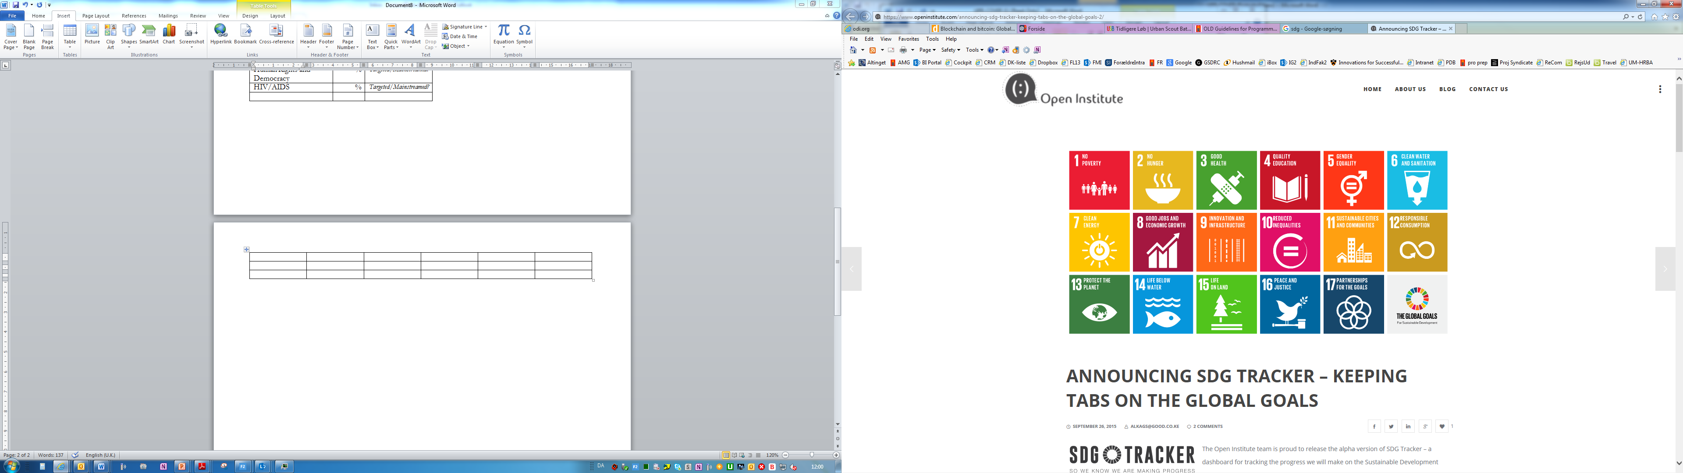  No Poverty | No  Hunger | Good Health, Wellbeing |  |  | Quality Education |  | Gender Equality |  |  | Clean Water, Sanitation
 |  | Affordable Clean Energy | Decent Jobs, Econ. Growth | Industry, Innovation, Infrastructure |  |  | Reduced Inequalities |  | Sustainable Cities, Communities |  |  | Responsible Consumption  & Production
 |  | Climate Action | Life below Water | Life on Land |  |  | Peace & Justice, strong Inst. |  | Partnerships for Goals
Project objective [of project under a Programme]
[Text]

Rio marker: 0, 1 or 2 | 0 (0%) | 1 (50%) | 2 (100%)
Climate adaptation (DKK)
Climate mitigation (DKK)
Greening overview: completion of Rio markers on climate.
Justification for choice of partner (method of selection):

[Text]

Summary:

[Text]

Budget

 |  |  |  |  |  | [insert DKK million]
 |  |  |  |  |  | [insert DKK million]
 |  |  |  |  |  | [insert DKK million]
Total |  |  |  |  |  | [insert DKK million]
Note: Budget based on project budget in Annex D.

