Quick guide for projects and programmes above DKK 100 million
Units responsible for preparing projects and programmes above DKK 100 million must submit a 2-page identification note for early feed-back during a kick-off meeting with MFA senior management, relevant policy department (eg. AFRPOL or MENA), LÆRING and TILSKUD. An early draft programme document (max. 15 pages) or project document (max. 10 pages) is submitted to LÆRING for early appraisal, public hearing and for presentation to the External Panel for early inputs. The responsible unit finalises the programming of the project/programme documentation based on inputs from early appraisal and External Panel and submits to LÆRING for final desk verification.
See Bilateral Guidelines on the AMG site for page references and annexes/templates. See separate process for Top-ups under Tools and Templates.

Overview of the project cycle:
What are requirements to early draft documentation submitted for early appraisal?
Programme with underlying projects:
- Early draft MFA programme document incl. context analysis and PAP in annex
- For each underlying project: early draft MFA project document and if drafted, partner assessment, preliminary results framework, budget at outcome level, preliminary risk management matrix; (early) partner project documentation (with annexes).
Stand-alone project:
- Same requirements as above for projects under a programme plus context analysis and PAP. Early draft partner project documentation (with annexes) is mandatory.
Call for Proposals:
- Draft Information Note including context analysis, preliminary results framework at outcome level and PAP.

Completion: See Chapter 5 in the guidelines.
Documents required:
- Final report from implementing partner (p. 36)
- Project completion summary p. 36)
- Financial closure (p. 37)

Identification: Submission of 2 pager + PAP - see chapter 2 in the guidelines.
Implementation: See chapter 4 in the guidelines. Mandatory actions:
- Annual planning and budgeting (p. 25)
- Monitoring, reporting, dialogue, annual stock-taking, learning etc. (p. 26-30)
- Mid-term and technical reviews (p. 31)
- Adjustments during implementation (p. 31-34)

Formulation and approval: See chapter 3 in the guidelines. Specification of the formulation and approval process, including the documentation required on page 10-15.

Specification of the preparation and approval process in step 1 and 2:
Required documents: Early draft programme/project document(s) with Appropriation Cover Note
Public consultation

Actions:  Responsible unit identifies project/programme and prepares a Process Action Plan and 2-page Identification Note  Output:  Process Action Plan (PAP)  2-page Identification Note for Kick-off meeting | Actions:  Kick-off meeting  Required documents:  Process Action Plan (PAP)  2-page Identification Note  Output:  Feed-back documented in minutes of meeting (drafted by LÆRING) | Actions:  Responsible unit formulates programme/project based on partner programme/project documentation  Output:  Programme level:  Appropriation Cover Note for programmes  Early draft MFA programme document including annexes:  Context Analysis  PAP  Project level:  Appropriation Cover Note for projects  Early draft MFA Project document w. annexes (preliminary versions, if drafted):  MFA Partner Assessment  MFA Results Framework  MFA Budget Details  MFA Risk Management  MFA Context Analysis*  Partner project description  MFA Process Action Plan*  * Only for stand-alone projects  Partner agreement(s) (draft) | Actions:  LÆRING conducts early appraisal  Required documents:  (See box above)  Same as listed under previous column ‘Formulation early draft for early appraisal’  Annexes at project level may be preliminary versions, if drafted)  Output:  Early appraisal report including table w. summary of recommendations | Actions:  Meeting in External Panel  Required documents:  Appropriation Cover Note  Early draft MFA programme/project document*  Summary of early appraisal recommendations  Responses from public hearing  Output:  Recommendations from Panel documented in minutes of meeting drafted by LÆRING  * For stand-alone projects incl. annex F (partner project document) | Actions:  Responsible unit finalises programming and incorporates recommendations and follow up actions from early appraisal, External Panel and public hearing  Output:  Appropriation Cover Note  Final programme/project documentation incl. annexes  Summary of early appraisal recommend-dations, incl. unit’s response, signed  Summary of the External Panel’s recommendation, incl. unit’s response, signed  Partner agreement(s) (draft) | Actions:  LÆRING conducts Desk Verification  Required documents:  Appropriation Cover Note  Final programme/project documentation incl. annexes  Summary of early appraisal recommend-dations, incl. unit’s response, signed  Summary of the External Panel’s recommendation, incl. unit’s response, signed  Output:  Desk verification documentation | Actions:  Responsible unit submits for approval by Minister through ‘Bevillings-sekretariatet’  Required documents:  Submission note (”forelæggelsesnotits”)  Appropriation Cover Note  Programme/project document incl. annexes  Summary of early appraisal recommend-dations, incl. unit’s response  Summary of the External Panel’s recommendation, incl. unit’s response  Desk verification report  Checklist for approval of grants above DKK 20 million  Output:  Minister’s approval  In cases with no direct legal basis in the Finance act, an ‘aktstykke’ is presented to the Parliamentary Finance Committee

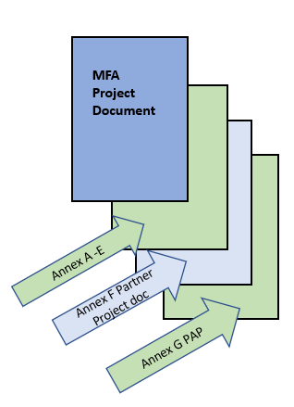
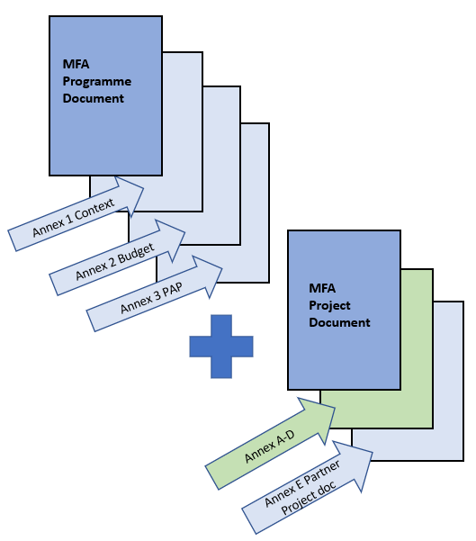
Stand-alone Project
Appropriation Cover Note, projects
Standard MFA Project Document w. annexes
- Annex A: MFA partner assessment
- Annex B: MFA detailed results framework
- Annex C: MFA project budget
- Annex D: MFA Risk management matrix
- Annex E: MFA Context analysis
- Annex F: Partner’s project description (with annexes)
- Annex G: Process Action Plan

Programme w. underlying projects
Appropriation Cover Note, programmes
Standard MFA Programme Document w. annexes
- Annex 1: Context analysis
- Annex 2: Programme budget
- Annex 3: Process Action Plan

Underlying Project Documents
Appropriation Cover Page, projects
Standard MFA Project Document w. annexes
- Annex A: MFA partner assessment
- Annex B: MFA results framework
- Annex C: MFA project budget
- Annex D: MFA Risk management matrix
- Annex E: Partner’s project description (with annexes)

