HOW TO APPLY A THEORY OF CHANGE IN COUNTRY PROGRAMMES, AND PROGRAMMES AND PROJECTS

What is Theory of Change all about for Danida?
Development assistance is about contributing to change for our partners. Theory of Change (ToC) is about articulating the many stages, steps and assumptions about how this change will happen.
We in Danida will use the Theory of Change (ToC) approach to explain how results of our programmes contribute to these changes. The ToC will reflect the intervention logics for achieving our intended results; how the contribution to the results framework brings us from our inputs to medium-term outcomes and sustainable impacts, and which assumptions and risks will determine our success. Special attention will be given to explain and provide evidence for causalities within results chains. In this way we see the ToC as an explanatory Logical Framework with a strong focus on how we get from one step in the intervention logic to another (e.g. from output to outcome) and a serious assessment of assumptions and risks for this process.
The ToC will help us prepare the narrative that will underpin our result framework – telling contribution stories for our support to change and the rationale/justification for our engagement.
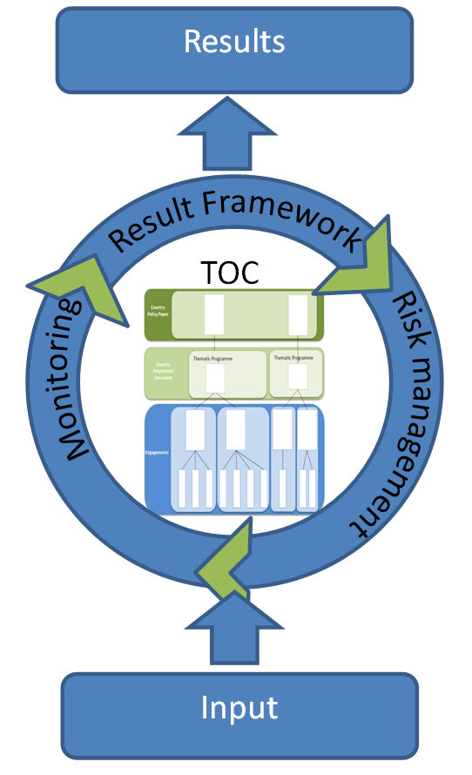
With this in mind our ToC will determine our results framework - what are the contributions and in some cases attributions from our development assistance to change for our partners? We will monitor if these come true through our monitoring and evaluation system (M&E), measuring verifiable indicators for results themselves, but also for the assumptions and risks that will determine that we achieve our expected outcomes and impacts. We will apply the ToC approach and related results framework and M&E systems in a pragmatic way in close dialogue with our partners. ToC is a simple logical approach but it is often applied in a complex world. This calls for realism and a results framework which is supported by credible contributions in the ToC process. We need a ToC process to prepare a results framework and we need a results framework to define our M&E system. But they are not blue prints. They are interrelated and may change if the context and reality for our support programmes changes and we need to adjust or redesign.
In our programmes the ToC will help us explaining and document the linkages between strategic objective, thematic objectives, outcomes and outputs as outlined in the Results Framework. ToC focusses on evidence for the causal links of the intervention logics upon which we build our programmes. In order words it forces us to critically reflect on how the programme will move from outputs to outcomes and eventually to thematic and strategic objectives, and how preconditions, assumptions and risks will influence this journey.

10 questions to guide your Theory of Change

- What are the changes we want to contribute to?

- How do we think change will happen in the specific context?

- What is our role?

- What are the conditions that must be realized before the result is achieved?

- Who to work with?

- What is inside and outside our influence?

- Do outputs lead to outcomes leading to thematic objectives to strategic objectives?

- What assumptions are we making for change to happen?

- What factors might hinder achieving the planned changes?

- Why is choosen approach, the best one to achieve the objectives?
How to write a narrative in a ToC
A narrative is the “executive summary” of the theory of change. It explains the intervention logic, the key preconditions and implicit assumptions that determine the interventions and the expected results. It resembles and overlap with the rationale/justification requested in the programme documentation.
The narrative is the last thing to be written when preparing a ToC. At this point, the intervention logic should be clear to all participants involved in preparing the ToC.
The narrative should be short, preferable no more than one page. The narrative does not replace a description of activities, structure for programme management etc. which will be unfolded in separate sections.
ToC is a reflection process for those involved in planning, which leads to a joint understanding of how we think we can bring about a desired change. The outcome of this process could result in a graphical illustration of our thinking. However, most graphical ToCs are hard to understand. Therefore, a narrative is imperative for communicating what we want to change and how we think we can bring about that change.
Secondly, the purpose of a narrative is to highlight the rationale behind our thinking. Consciousness about our rationale enables us to reflect and learn as we move on to implement our programme with our partners. It enables us to ask the question: does change really happen the way we anticipate? And it helps us to nurture a dialogue among ourselves and with our partners on the expected results of our support.
Tips when drafting a narrative
- Start with the long-term goal of the programme/intervention
- Describe what needs to change (the preconditions/outputs you need to create) to reach the goal, test whether you give a reply to the 10 questions.
- Describe the logic in “change flows” when relevant. This can be done by constructing sentences using “so-that”.
- Articulate key assumptions and risks in the ToC.

