[Insert title of project]

Key results:  [Examples of key result planned to be achieved at the end of project:]  -  -  -  Justification for support:  [Why is this support necessary and relevant, how does it relate to Danish and partner country priorities:]  -  -  -  Major risks and challenges:  [What are the main risks and challenges for this project to achieve intended results and objectives, are mitigation measures possible to manage risks:]  -  -  - |  | File No.
 |  | Country
 |  | Responsible Unit
 |  | Sector
 |  | Partner
 |  | DKK mill. |  |  | 20xx | 20xx |  |  | 20xx |  | 20xx | 20xx |  | Tot.
 |  | Commitment
 |  | Projected ann. disb.
 |  | Duration
 |  | Previous grants
 |  | Finance Act code
 |  | Head of unit
 |  | Desk officer
 |  | Reviewed by CFO |  |  | NO / YES: Name of CFO
 |  | Relevant SDGs [Maximum 5 – highlight with grey]
 |  | 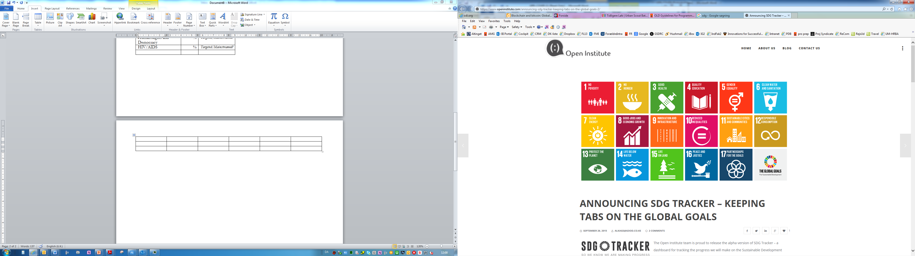  No Poverty | No  Hunger | Good Health, Wellbeing |  |  |  | Quality Education |  | Gender Equality |  |  | Clean Water, Sanitation
 |  | Affordable Clean Energy | Decent Jobs, Econ. Growth | Industry, Innovation, Infrastructure |  |  |  | Reduced Inequalities |  | Sustainable Cities, Communities |  |  | Responsible Consumption  & Production
 |  | Climate Action | Life below Water | Life on Land |  |  |  | Peace & Justice, strong Inst. |  | Partnerships for Goals
Strategic objectives:
[Text]
Justification for choice of partner:
[Text]

Summary:

[Text]

Budget:

Output 1 |  |  |  |  |  |  | [insert DKK mill.]
Output 2 |  |  |  |  |  |  | [insert DKK mill.]
Output 3 |  |  |  |  |  |  | [insert DKK mill.]
Output 4 |  |  |  |  |  |  | [insert DKK mill.]
Output 5 |  |  |  |  |  |  | [insert DKK mill.]
Total |  |  |  |  |  |  | [insert DKK mill.]

