[Insert title of programme]

Key results:  [Examples of key results – outcome - planned to be achieved at the end of programme]  -  -  -  Justification for support:  [Why is this programme necessary and relevant; how does it relate to Danish and priority country priorities, if applicable]  -  -  -  Major risks and challenges:  [What are the main risks and challenges for this programme to achieve intended the results and objectives, are mitigation measures possible to manage risks]  -  -  - | File No.
 | Country
 | Responsible Unit
 | DAC-CRS code |  |  | [e.g., 12220 basic health]
 | DKK million |  |  | 20xx | 20xx |  | 20xx |  | 20xx | 20xx |  | Total
 | Commitment
 | Projected disbursement
 | Duration
 | Previous grants
 | Finance Act code (only one)
 | Head of unit
 | Desk officer
 | Reviewed by CFO |  |  | NO / YES: Name of CFO
 | Relevant SDGs [Maximum 5 based on project SDG– highlight with grey]
 | 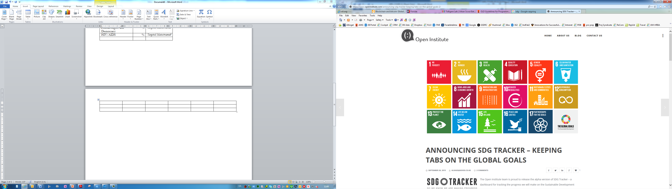  No Poverty | No  Hunger | Good Health, Wellbeing |  |  | Quality Education |  | Gender Equality |  |  | Clean Water, Sanitation
 | Affordable Clean Energy | Decent Jobs, Econ. Growth | Industry, Innovation, Infrastructure |  |  | Reduced Inequalities |  | Sustainable Cities, Communities |  |  | Responsible Consumption  & Production
 | Climate Action | Life below Water | Life on Land |  |  | Peace & Justice, strong Inst. |  | Partnerships for Goals
Overall objective and strategic objectives of the programme
[Text]

 | DKK (million) | % of allocated budget
Climate adaptation
Climate mitigation
Contribution to climate change adaptation and mitigation finance (aggregated across projects)

 | Partner | Total budget: [DKK million]
Project 1 (engagement as defined in PMI):
Project 2
Project 3
etc
 | Programme support (Reviews, monitoring etc)
 | Total

