Quick guide for projects up to DKK 20 million (inclusive)
Projects up to and including DKK 20 million are prepared by the responsible unit and quality assured by the responsible unit through the completion of the ‘Quality assurance checklist for projects up to DKK 20 million’.
See Bilateral Guidelines on the AMG site for page references and annexes/templates. See separate process for Top-ups under Tools and Templates.

Overview of the project cycle:
Completion: See Chapter 5 in the guidelines.
Documents required:
- Final report from implementing partner (p. 36)
- Project completion summary (p.36)
- Financial closure (p. 37)

Identification not mandatory for projects under DKK 20 million.
Implementation: See chapter 4 in the guidelines. Mandatory actions:
- Annual planning and budgeting (p. 25)
- Monitoring, reporting, dialogue, learning etc. (p. 26-30)
- Adjustments during implementation (p. 31-34)

Formulation and approval: See chapter 3 in the guidelines. Specification of the formulation and approval process, including the documentation required on page 10-15.

Specification of the preparation and approval process in step 1 and 2:

Actions:  Responsible unit prepares a Process Action Plan, identifies implementing partner and develops identification note, if found relevant  Output:  Process Action Plan (PAP)  Optional identification note | Actions:  Responsible unit formulates draft project document based on partner project document  Output:  Appropriation Cover Note for projects  Draft MFA Project document w. annexes:  MFA Partner Assessment  MFA Results Framework  MFA Budget Details  MFA Risk Management*  MFA Context Analysis*  Partner project description  Process Action Plan  Partner agreement (draft)  * not mandatory for projects below DKK 20 million (inclusive) | Actions:  Responsible unit completes the Quality assurance checklist (must be carried out by other staff member than the staff member responsible for the formulation of the project).  Required documents:  Draft project document with Appropriation Cover Note, annexes and other relevant documentation  Output:  Quality assurance checklist signed by Head of Unit | Actions:  Finalise project documentation  Output:  Appropriation Cover Note  Final project document with annexes  (Partner agreement(s)) | Actions:  Responsible unit submits for approval through ‘Bevillingssekretariatet’  Required documents:  Appropriation Cover Note  Project document with annexes  Quality assurance checklist  Approval:  Grants up and including DKK 10 million: Head of Unit  Grants above DKK 10 million: Minister

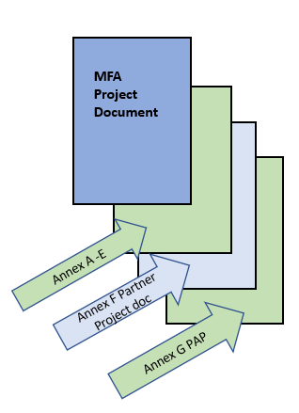
Stand-alone Project
Appropriation Cover Note, projects
Standard MFA Project Document w. annexes
- Annex A: MFA partner assessment
- Annex B: MFA detailed results framework
- Annex C: MFA project budget
- Annex D: MFA Risk management matrix*
- Annex E: MFA Context analysis*
- Annex F: Partner’s project description (with annexes)
- Annex G: Process Action Plan
* Annex D and E not mandatory for projects below DKK 20 million (inclusive)

