Danish Organisation Strategy
for XXXXX
[This ”one-pager” is prepared for all organisation strategies]
Introduction:  Key results:  [Examples of key result planned to be achieved at the end of programme:]  Justification for support:  [Why is this support necessary and relevant, how does it relate to Danish and partner country priorities:]  How will we ensure results and monitor progress:  [How will the programme succeed and how will this be documented:]  Risk and challenges:  [What are the main risks and challenges for this programme to achieve intended results and objectives, are mitigation measures possible to manage risks:] |  |  |  |  | File No.
 |  |  |  |  | Responsible Unit
 |  |  |  |  | Mill. |  |  | 20xx |  | 20xx |  | 20xx | 20xx |  | total
 |  |  |  |  | Commitment
 |  |  |  |  | Projected ann. Disb.
 |  |  |  |  | Duration of strategy
 |  |  |  |  | Finance Act code.
 |  |  |  |  | Desk officer
 |  |  |  |  | Financial officer
 |  |  |  |  | SDGs relevant for Programme
 |  |  |  |  | 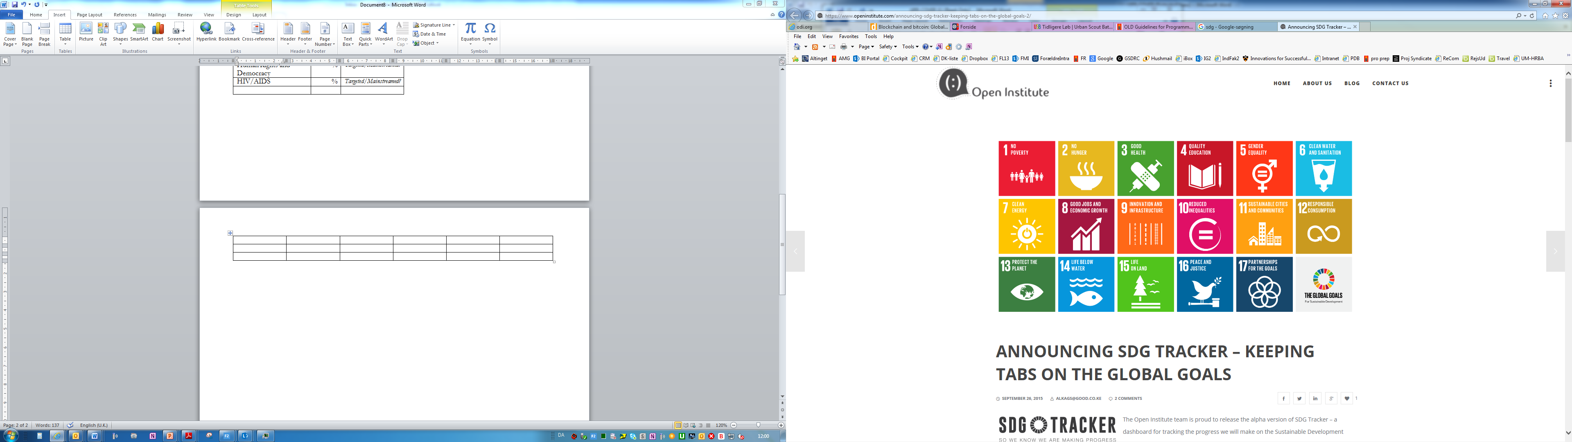  No Poverty | No  Hunger | Good Health, Wellbeing |  | Quality Education |  | Gender Equality |  |  | Clean Water, Sanitation
 |  |  |  |  | Affordable Clean Energy | Decent Jobs, Econ. Growth | Industry, Innovation, Infrastructure |  | Reduced Inequalities |  | Sustainable Cities, Communities |  |  | Responsible Consumption  & Production
 |  |  |  |  | Climate Action | Life below Water | Life on Land |  | Peace & Justice, strong Inst. |  | Partnerships for Goals
 |  |  |  |  | Budget
 |  |  |  |  | Danish involvement in governance structure
Strat. objectives |  | Priority results |  | Core information

