ANNEX 1D

Grant application – Full Project Proposal
Amazonian Gastronomy School
(Max. 15 pages excl. appendices)

Information about APPLICANT
Lead applicant
Address:
Contact person:
- Name
- E-mail
- Phone
Co-applicants | Delete if not relevant

Basic INFORMATION ABOUT THE PROJECT
Project title
Total amount applied for (DKK)
Other funding for the project (DKK)
SDG alignment
Specify relevant targets and indicators
Main partners

Geographical coverage of the project
Estimated start date and duration (months)

- Context, strategic considerations and justification
- Brief summary of the main issues at national/regional/global level, as relevant, pertaining to political, societal, economic, environmental, humanitarian, security and human rights aspects that are relevant for the project. Include reflection of specific opportunities, challenges and risks these will imply for the project to achieve long-term sustainable results and make lasting impact.
- Presentation of the development problem(s) to be addressed by the project.
- Brief presentation of past lessons learned, both positive and negative, and explanation of how they have influenced the design of the project.
- Adherence to the aid effectiveness agenda, including complementarity with other ongoing efforts, alignment to national/regional/global objectives and coordination with relevant stakeholders.

- Project description and intervention logic
- Presentation of the theory of change, i.e., how the identified development problem is expected to be addressed and pathways through which the intended changes will take place.
- Presentation of project approach/methodology such as private sector engagement, local economic development, nature-based solutions, integrated water resource management, gender transformative approaches, advocacy/policy dialogue, conflict prevention, etc.
- Alignment with Danish cross-cutting priorities, incl. human rights-based approach (HRBA), Leaving No-one Behind (LNOB), gender and youth, climate change and environmental considerations.
- Presentation of expected results at output level and how they link up to the MFA defined objectives/impact and outcomes, i.e., linking up to the project’s results framework (see template in appendix A)
- Highlight key assumptions made in order for changes to take place and if relevant, how different scenarios may influence project implementation.
- Description of the types of activities that are expected to be carried out to achieve change.
- Description of project beneficiaries.

- Local partnerships and ownership
- Description roles and responsibilities of project partners (applicant(s), sub-grantees, national/local partners etc.) in project implementation.
- Strategies for capacity development of local partners/stakeholders.
- Description of involvement of target groups.
- [If relevant - Description of the proportion of the budget to be transferred to partners and used locally as reflected in budget; see template in appendix C]

- Management arrangements
- Presentation of the organisational and governance set-up for the project
- Description of mechanisms quality assurance and risk management, including security/safety related issues.
- Summary of anti-corruption measures and other measures for respecting Danish red lines (child labour, SEAH, anti-terrorism) in line with Danida Aid Management Guidelines.
- If the application is on behalf of a group (i.e., with a lead applicant and one or more co-applicants), presentation of proposed roles and division of labour within the consortium.

- Monitoring, evaluation, accountability and learning
- Presentation of mechanisms and procedures for monitoring, reporting/documentation and evaluation
- Presentation of how learning will be collected, applied and disseminated
- Outline of a plan for communicating results.

- Risk Management
- Short narrative description of key risks and how they will be managed based on the summary of risk analysis, risk response at contextual, programmatic and institutional level in the risk management matrix (see template in appendix B).
- Exit
- Brief description of how sustainability issues are taken into account and how eventual phase-out will be facilitated.

Date :

Signature of lead applicant:

Appendices:
Appendix A: Results Framework
Appendix B: Risk Management Matrix
Appendix C: Budget

Appendix A: Results Framework
[Project objective and outcome(s) are defined by the MFA in a CfP; adjust the number of outcomes and outputs under each outcome as appropriate (tip: select blank space and the relevant rows underneath, copy, then paste with right-click and “Insert as New Rows” function on the last “target row” of the outcome/output] The outputs, output indicators and targets must be filled out by the applicant(s).
Project |  | [Project title]
Objective |  | [The intended impact contributing to benefits to a society or community]
Impact Indicator |  | [Macro indicator, e.g., recipient country indicator, SDG indicator etc.]
Baseline | Year |  | [Situation prior to project activities]
Target | Year |  | [Intended situation by the end of project]
Outcome 1 (maximum three Outcomes in total) |  | [The short-term and medium-term effects of project outputs on the target group]
Outcome indicator |  | [Quantitative or qualitative factor or variable that provides a simple and reliable means to measure achievement or to reflect the changes connected to an intervention]
Baseline | Year |  | [Situation prior to project activities]
Target | Year |  | [intended situation by the end of project]
Output 1.1 (maximum three Outputs under each Outcome) |  | [Short-term result in the form of goods and services which result from a project activity]
Output indicator |  | [Quantitative or qualitative factor or variable that provides a simple and reliable means to measure achievement or to reflect the changes connected to an intervention]
Baseline | Year |  | [Situation prior to project activity]
Target | Year 1 |  | [Intended situation after first year of implementation]
Target | Year 2 |  | [Intended situation after two years of implementation]
Target | Year 3 |  | [Intended situation after three years of implementation]
… | …. |  | ….
Target | Year |  | [Intended situation when activity under the project ends]
Output 1.2 |  | [Short-term result in the form of goods and services which result from a project activity]
Output indicator |  | [Quantitative or qualitative factor or variable that provides a simple and reliable means to measure achievement or to reflect the changes connected to an intervention]
Baseline | Year |  | [Situation prior to project activity]
Target | Year 1 |  | [Intended situation after first year of implementation]
Target | Year 2 |  | [Intended situation after two years of implementation]
Target | Year 3 |  | [Intended situation after three years of implementation]
… | …. |  | ….
Target | Year |  | [Intended situation when activity under the project ends]
Output 1.3 |  | [Short-term result in the form of goods and services which result from a project activity]
Output indicator |  | [Quantitative or qualitative factor or variable that provides a simple and reliable means to measure achievement or to reflect the changes connected to an intervention]
Baseline | Year |  | [Situation prior to project activity]
Target | Year 1 |  | [Intended situation after first year of implementation]
Target | Year 2 |  | [Intended situation after two years of implementation]
Target | Year 3 |  | [Intended situation after three years of implementation]
… | …. |  | ….
Target | Year |  | [Intended situation when activity under the project ends]
Outcome 2 |  | [The short-term and medium-term effects of project outputs on the target group]
Outcome indicator |  | [Quantitative or qualitative factor or variable that provides a simple and reliable means to measure achievement or to reflect the changes connected to an intervention]
Baseline | Year |  | [Situation prior to project activities]
Target | Year |  | [intended situation by the end of project]
Output 2.1 |  | [Short-term result in the form of goods and services which result from a project activity]
Output indicator |  | [Quantitative or qualitative factor or variable that provides a simple and reliable means to measure achievement or to reflect the changes connected to an intervention]
Baseline | Year |  | [Situation prior to project activity]
Target | Year 1 |  | [Intended situation after first year of implementation]
Target | Year 2 |  | [Intended situation after two years of implementation]
Target | Year 3 |  | [Intended situation after three years of implementation]
… | …. |  | ….
Target | Year |  | [Intended situation when activity under the project ends]
Output 2.2 |  | [Short-term result in the form of goods and services which result from a project activity]
Output indicator |  | [Quantitative or qualitative factor or variable that provides a simple and reliable means to measure achievement or to reflect the changes connected to an intervention]
Baseline | Year |  | [Situation prior to project activity]
Target | Year 1 |  | [Intended situation after first year of implementation]
Target | Year 2 |  | [Intended situation after two years of implementation]
Target | Year 3 |  | [Intended situation after three years of implementation]
… | …. |  | ….
Target | Year |  | [Intended situation when activity under the project ends]
Output 2.3 |  | [Short-term result in the form of goods and services which result from a project activity]
Output indicator |  | [Quantitative or qualitative factor or variable that provides a simple and reliable means to measure achievement or to reflect the changes connected to an intervention]
Baseline | Year |  | [Situation prior to project activity]
Target | Year 1 |  | [Intended situation after first year of implementation]
Target | Year 2 |  | [Intended situation after two years of implementation]
Target | Year 3 |  | [Intended situation after three years of implementation]
… | …. |  | ….
Target | Year |  | [Intended situation when activity under the project ends]

Appendix B: Risk management matrix
Contextual risks
Risk Factor | Likelihood | Impact | Risk response | Residual risk | Background to assessment
Political
Economic
Societal
Environment
Security
Programmatic risks
Risk Factor | Likelihood | Impact | Risk response | Residual risk | Background to assessment
Institutional risks
Risk Factor | Likelihood | Impact | Risk response | Residual risk | Background to assessment

For guidance on how to fill out the matrix, refer to the “Bilateral” Standard Annexes, annex 4: Guidelines for programmes, projects, country strategic frameworks & hard earmarked multilateral support (amg.um.dk)
Appendix C: budget
[Instead of the image below, the attached appendix template should be based on the MFA’s standard Excel/spreadsheet template; see annex 2B and confer annex 2A of the General Guidelines for Financial management (amg.um.dk). The Responsible Unit may modify the template as deemed appropriate, but consultation with the unit’s CFO is encouraged.
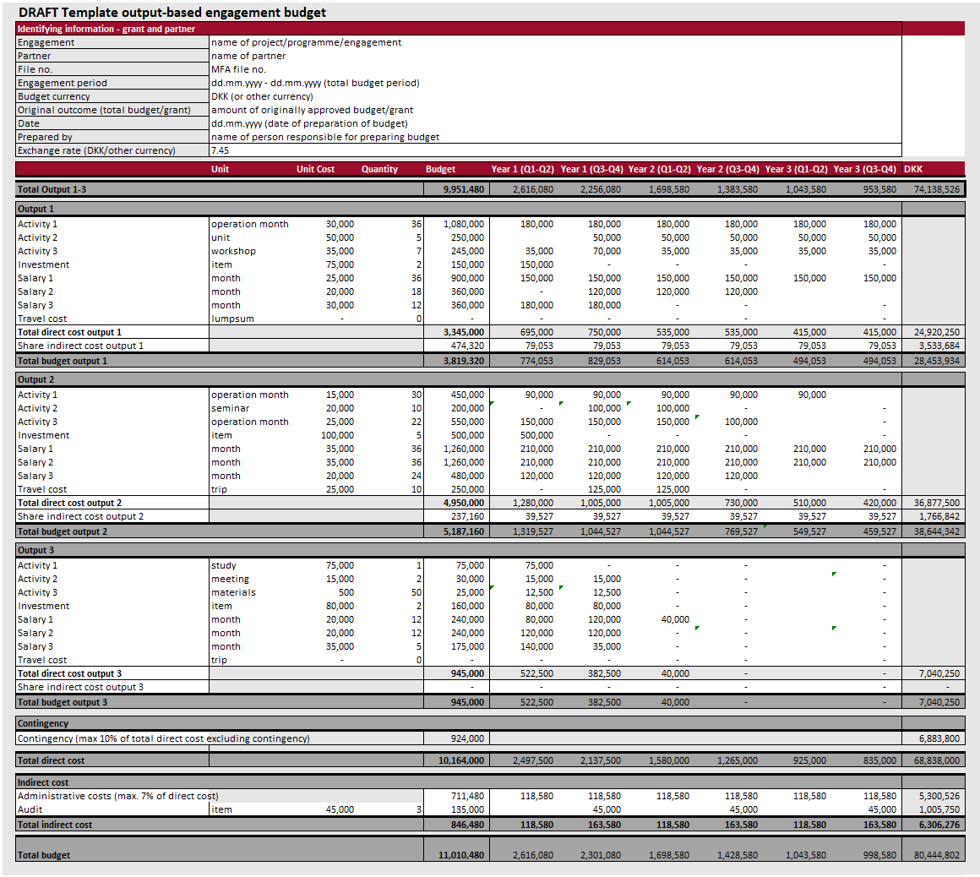
Please also note that the “Bilateral” Standard Annexes, annex 5 (specifically section 1 on “Single-partner projects”), of the Guidelines for programmes, projects, country strategic frameworks and hard earmarked multilateral support (amg.um.dk) is intended for the MFA’s internal project documents, and the template found therein should not be used in relation to CfPs.]

