Quick guide for projects and programmes between DKK 20 to DKK 100 million
Units responsible for preparing projects and programmes from DKK 20 to DKK 100 million (inclusive) must submit a 2-page Identification Note for early feed-back during a kick-off meeting with MFA senior management, relevant policy department (eg. AFRPOL or MENA), LÆRING and TILSKUD. Based on a risk assessment of the project (Annex 1 to Identification Note), the quality assurance process will follow either the process for appropriations above DKK 100 million (high risk projects) or be subject to appraisal by external consultants (medium risks). The draft programme document (max. 10 pages) or project document (max. 5 pages) is subject to appraisal by external consultants recruited by the responsible unit.
See Bilateral Guidelines on the AMG site for page references and annexes/templates. See separate process for Top-ups under Tools and Templates.

Overview of the project cycle:
Completion: See Chapter 5 in the guidelines.
Documents required:
- Final report from implementing partner (p. 36)
- Project completion summary (p.36)
- Financial closure (p. 37)

Identification and submission of 2 pager + PAP and Annex 1 (risk assessment): See chapter 2 in the guidelines.

Implementation: See chapter 4 in the guidelines. Mandatory actions:
- Annual planning and budgeting (p. 25)
- Monitoring, reporting, dialogue, annual stock-taking, learning etc. (p. 26-30)
- Mid-term and technical reviews (p. 31)
- Adjustments during implementation (p. 31-34)

Formulation and approval: See chapter 3 in the guidelines. Specification of the formulation and approval process, including the documentation required on page 10-15.

Specification of the preparation and approval process in step 1 and 2:

Actions:  Responsible unit identifies project/programme and prepares a Process Action Plan and 2-page Identification Note including Risk assessment for Kick-off meeting as Annex 1  Output:  Process Action Plan (PAP)  2-page Identification Note including Annex 1, Risk Assessment, for Kick-off meeting | Actions:  Kick-off meeting  Required documents:  Process Action Plan (PAP)  2-page Identification Note  Risk assessment (Annex 1)  Output:  Feed-back documented in minutes of meeting (drafted by LÆRING) | Actions:  Responsible unit formulates programme/project based on partner programme/project documentation  Output:  Programme level:  Appropriation Cover Note for programmes  Draft MFA programme document including annexes:  Context Analysis  Programme budget  PAP  Project level:  Appropriation Cover Note for projects  Draft MFA Project document w. annexes:  MFA Partner Assessment  MFA Results Framework  MFA Budget Details  MFA Risk Management  Context Analysis*  Partner project description  Process Action Plan*  Partner agreement(s) (draft)  * Only for stand-alone projects | Actions:  Responsible unit contracts external consultant to undertake appraisal  Required documents:  Same as listed under previous column ‘Formulation early draft for early appraisal’  Output:  Appraisal report including table w. Summary of appraisal recommendations | Actions:  Responsible unit updates project documentation w. incorporation of recommendations and follow up actions from external appraisal  Output:  Appropriation Cover Note  Final programme/project documentation including annexes  Summary of appraisal recommend-dations, incl. unit’s response, signed  Partner agreement(s) (draft) | Actions:  Responsible unit submits for approval by Minister through ‘Bevillingssekretariatet’  Required documents:  Submission note (”forelæggelsesnotits”)  Appropriation Cover Note  Programme/project document incl. annexes  Summary of appraisal recommend-dations, incl. unit’s response  Checklist for approval of grants above DKK 20 million  Output:  Minister’s approval  In cases with no direct legal basis in the Finance act (eg. ‘Rammebevillinger’) for grants above DKK 47 million, an ‘aktstykke’ is presented to the Parliamentary Finance Committee

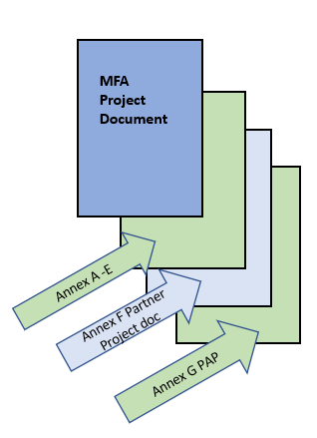
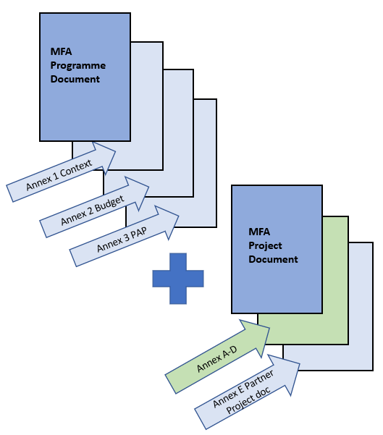
Programme w. underlying projects
Appropriation Cover Note, programmes
Standard MFA Programme Document w. annexes
- Annex 1: Context analysis
- Annex 2: Programme budget
- Annex 3: Process Action Plan

Underlying Project Documents
Appropriation Cover Note, projects
Standard MFA Project Document w. annexes
- Annex A: MFA partner assessment
- Annex B: MFA results framework
- Annex C: MFA project budget
- Annex D: MFA Risk management matrix
- Annex E: Partner’s project description (with annexes)

Stand-alone Project
Appropriation Cover Note, projects
Standard MFA Project Document w. annexes
- Annex A: MFA partner assessment
- Annex B: MFA detailed results framework
- Annex C: MFA project budget
- Annex D: MFA Risk management matrix*
- Annex E: MFA Context analysis*
- Annex F: Partner’s project description (with annexes)
- Annex G: Process Action Plan
* Annex D and E not mandatory for projects below DKK 20 million (inclusive)

