[Insert title of programme]

Key results:  [Examples of key results – outcome - planned to be achieved at the end of programme]  -  -  -  Justification for support:  [Why is this support necessary and relevant, how does it relate to Danish and partner country priorities, if applicable]  -  -  -  Major risks and challenges:  [What are the main risks and challenges for this programme to achieve intended results and objectives; are mitigation measures possible to manage risks]  -  -  - |  |  |  | File No.
 |  |  |  | Country
 |  |  |  | Responsible Unit
 |  |  |  | Sector
 |  |  |  | DKK million |  |  |  | 20xx | 20xx |  | 20xx |  | 20xx | 20xx |  | Total
 |  |  |  | Commitment
 |  |  |  | Projected Disbursement
 |  |  |  | Duration
 |  |  |  | Finance Act code.
 |  |  |  | Head of unit
 |  |  |  | Desk officer
 |  |  |  | Reviewed by CFO |  |  |  | NO / YES: Name of CFO
 |  |  |  | Relevant SDGs [Maximum 5 – highlight with grey]
 |  |  |  | 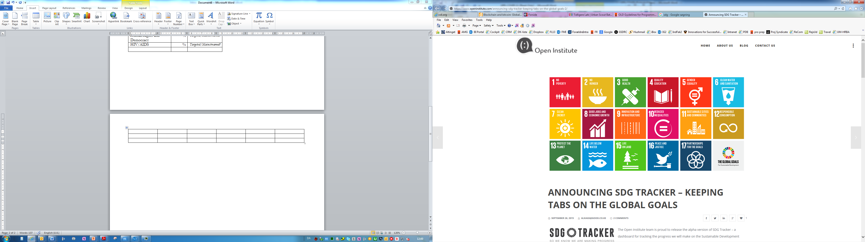  No Poverty | No  Hunger |  | Good Health, Wellbeing |  |  | Quality Education |  | Gender Equality |  |  | Clean Water, Sanitation
 |  |  |  | Affordable Clean Energy | Decent Jobs, Econ. Growth |  | Industry, Innovation, Infrastructure |  |  | Reduced Inequalities |  | Sustainable Cities, Communities |  |  | Responsible Consumption  & Production
 |  |  |  | Climate Action | Life below Water |  | Life on Land |  |  | Peace & Justice, strong Inst. |  | Partnerships for Goals
Objectives for stand-alone programme:

[Text]
Environment and climate targeting - Principal objective (100%); Significant objective (50%)
 | Climate adaptation | Climate mitigation |  |  |  | Biodiversity |  |  |  |  | Other green/environment
Indicate 0, 50% or 100%
Project 1
Project 2
Project 3
Total green budget (DKK)
Project 1 (engagement as defined in FMI): |  |  | Partner |  |  |  |  |  | Total thematic budget: [million]
Engagement 1 - the development project |  |  |  |  |  |  |  |  | [Budget engagement 1]
Engagement 2 - auxiliary activities: advisors, M&E., etc. areviews (repeat as relevant) |  |  |  |  |  |  |  |  | [Budget engagement 2]
Engagement 3 – un-allocated funds |  |  |  |  |  |  |  |  | [Budget engagement 3]
Total |  |  |  |  |  |  |  |  | [Budget Project 1]
Project 2 (engagement as defined in FMI): |  |  | Partner |  |  |  |  |  | Total thematic budget: [mill.]
Engagement 1 - the development project |  |  |  |  |  |  |  |  | [Budget engagement 1]
Engagement 2 - auxiliary activities: advisors, M&E, etc. reviews (repeat as relevant) |  |  |  |  |  |  |  |  | [Budget engagement 2]
Engagement 3 – un-allocated funds |  |  |  |  |  |  |  |  | [Budget engagement 3]
Total |  |  |  |  |  |  |  |  | [Budget Project 2]
Project 3 (engagement as defined in FMI): |  |  | Partner |  |  |  |  |  | Total thematic budget: [mill.]
Engagement 1 - the development project |  |  |  |  |  |  |  |  | [Budget engagement 1]
Engagement 2 - auxiliary activities: advisors, M&E, etc. reviews (repeat as relevant) |  |  |  |  |  |  |  |  | [Budget engagement 2]
Engagement 3 – un-allocated funds |  |  |  |  |  |  |  |  | [Budget engagement 3]
Total |  |  |  |  |  |  |  |  | [Budget Project 3]
 |  |  | Programme support |  |  |  |  |  | [Budget for Programme Support]
 |  |  | Total |  |  |  |  |  | [insert Total Budget]

Note: Add projects, as relevant.
Note: In PMI, an interactive version of this appropriation cover note is available at the “Grant” page under “Budget”.

