[Insert title of project]

Key results:  [Examples of key results – outcome - planned to be achieved at the end of project]  -  -  -  Justification for support:  [Why is this support necessary and relevant; how does it relate to Danish and priority country priorities, if applicable]  -  -  -  Major risks and challenges:  [What are the main risks and challenges for this project to achieve intended the results and objectives, are mitigation measures possible to manage risks]  -  -  - |  |  |  | File No.
 |  |  |  | Country
 |  |  |  | Responsible Unit
 |  |  |  | Sector
 |  |  |  | Partner
 |  |  |  | DKK million |  |  |  | 20xx | 20xx |  | 20xx |  | 20xx | 20xx |  | Total
 |  |  |  | Commitment
 |  |  |  | Projected disbursement
 |  |  |  | Duration
 |  |  |  | Previous grants
 |  |  |  | Finance Act code
 |  |  |  | Head of unit
 |  |  |  | Desk officer
 |  |  |  | Reviewed by CFO |  |  |  | NO / YES: Name of CFO
 |  |  |  | Relevant SDGs [Maximum 1 – highlight with grey]
 |  |  |  | 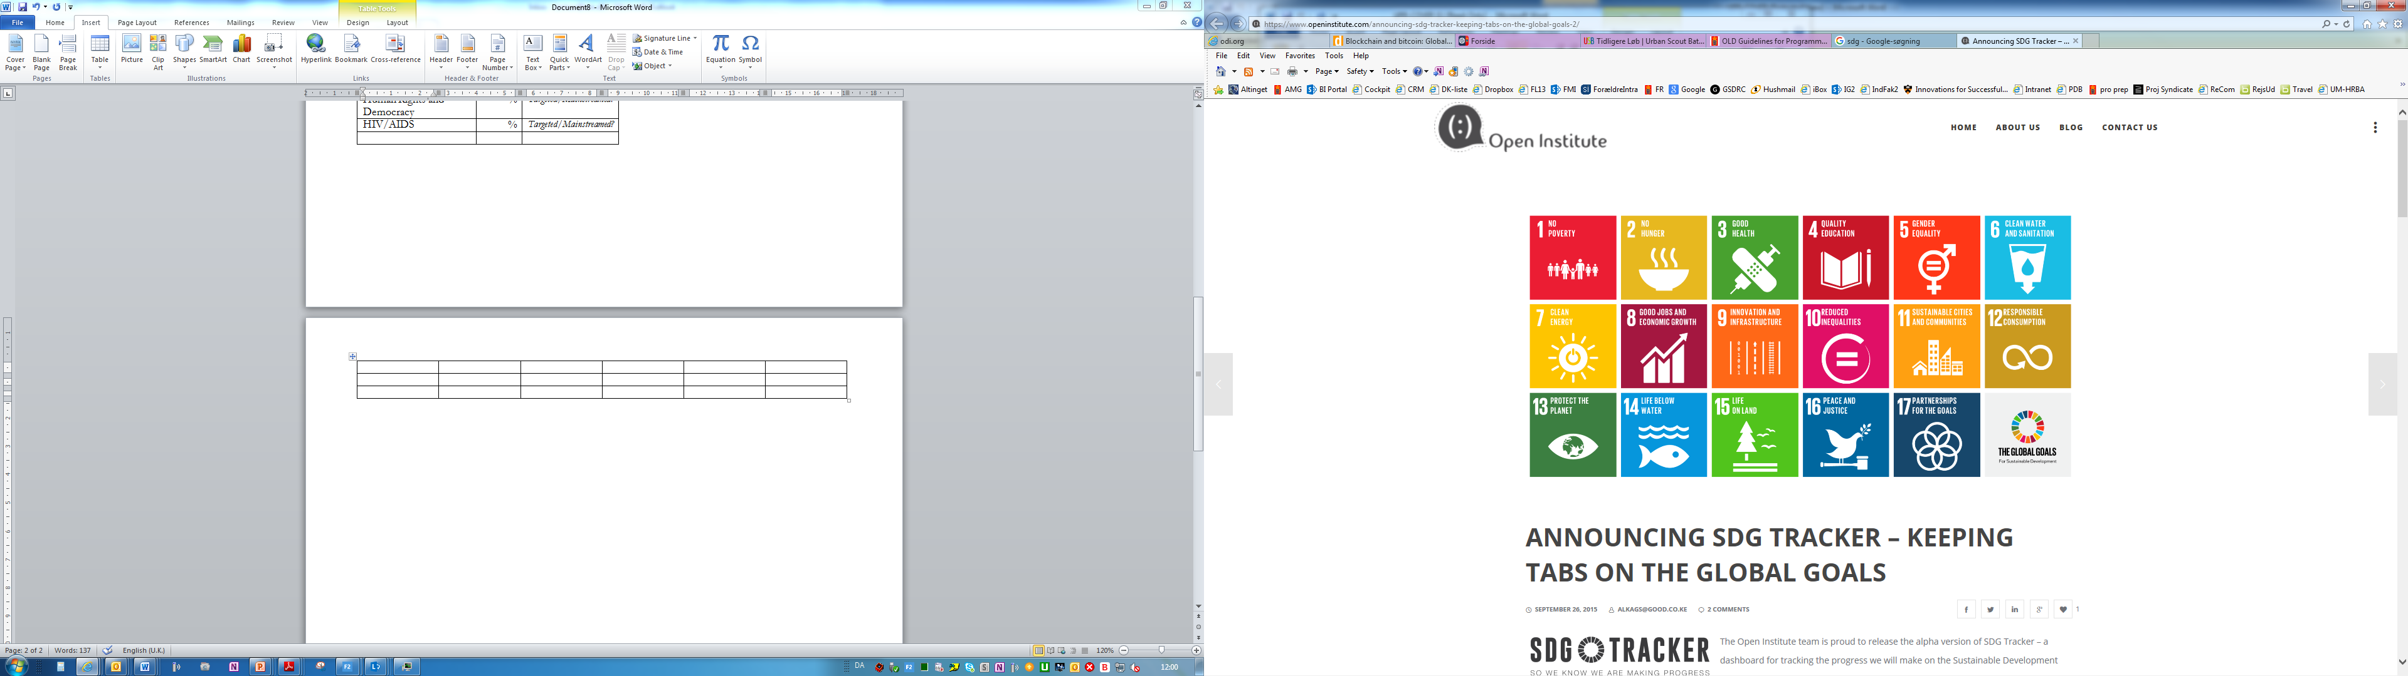  No Poverty | No  Hunger |  | Good Health, Wellbeing |  |  | Quality Education |  | Gender Equality |  |  | Clean Water, Sanitation
 |  |  |  | Affordable Clean Energy | Decent Jobs, Econ. Growth |  | Industry, Innovation, Infrastructure |  |  | Reduced Inequalities |  | Sustainable Cities, Communities |  |  | Responsible Consumption  & Production
 |  |  |  | Climate Action | Life below Water |  | Life on Land |  |  | Peace & Justice, strong Inst. |  | Partnerships for Goals
Strategic objectives [for projects under a Country Strategic Framework]/Objectives [for stand-alone projects] – Choose as relevant.
[Text]
Environment and climate targeting - Principal objective (100%); Significant objective (50%)
 | Climate adaptation | Climate mitigation |  |  |  | Biodiversity |  |  |  |  | Other green/environment
Indicate 0, 50% or 100%
Total green budget (DKK)
Justification for choice of partner:
[Text]

Summary:

[Text]

Budget (engagement as defined in FMI):

Engagement 1 – the development project |  |  |  |  |  |  |  |  | [insert DKK million]
Engagement 2 - auxiliary activities, such as advisors, M&E and reviews (repeat as relevant) |  |  |  |  |  |  |  |  | [insert DKK million]
Engagement 3 – un-allocated funds |  |  |  |  |  |  |  |  | [insert DKK million]
Total |  |  |  |  |  |  |  |  | [insert DKK million]

Note: In PMI, an interactive version of this appropriation cover note is available at the “Grant” page under “Budget”.

