Guidance on the Application of Rio Markers in Danish Development Cooperation

Introduction

1. Denmark maintains a strong green profile within development cooperation spending. A target of 30% of total development assistance (approximately DKK 5.5 billion in 2026) is allocated for climate investments, with at least 60% earmarked for climate adaptation.
1) At least 30% of the budget for the Danish development cooperation must be allocated to climate finance.
2) At least 60% of the climate finance must target climate adaptation.

2. Denmark applies the OECD-DAC Rio marker system for assessing whether development finance supports the Rio Conventions. The four Rio markers are: i) Biodiversity, ii) Desertification, iii) Climate Change Mitigation, and iv) Climate Change Adaptation. The OECD-DAC handbook on Rio markers provides specific guidance for how to apply the methodology to different to projects in different sectors and serves as the international standard.
3. To deliver on its 30% climate target, Denmark assesses all annual Finance Act commitments against the Rio markers for climate mitigation and adaptation. The overall calculation of the climate share within total development cooperation is based on the individual Rio marker scoring of each project document (“Engagement in PMI”. This assessment is carried out during the project preparation and summarised on the appropriation cover note, where it is mandatory to complete the table below:
4. To ensure transparency in the scoring of the climate Rio markers, the responsible officer is expected to provide a justification of the scoring in the template available in the budget annex of the project/programme document.
5. In addition to the internal reporting process related to meeting the 30% climate target for the Danish Development Cooperation, Denmark applies the Rio marker scoring to report on climate finance to both the EU, OECD and UNFCCC.
Organisation | Frequency of Denmark’s climate finance reporting
OECD DAC | Denmark reports climate finance annually, covering the previous year. Denmark reports to OECD on all policy markers.
EU | Denmark reports climate finance annually, covering the previous year.
UNFCCC | Denmark reports climate finance every second year, covering a biennial period.

6. The Rio markers on biodiversity and desertification are recorded in the budget annex of the project/programme document template. Denmark does not set specific spending targets for allocating a share of the development cooperation budget to ‘desertification,’ ‘biodiversity,’ or ‘aid to environment.’ However, all projects should be scored against these markers in the budget annex of the project/programme document and when entered into the Project Management Interface (PMI) (at “Engagement level” for projects), as Denmark is obliged to report them to OECD, UNCBD and UNCCD
Methodology
8. The Rio markers are applied using a simple scoring system: 'Not targeted' (0), 'Significant' (1), and 'Principal' (2). These correspond to 0%, 50%, and 100% of the total budget of a given activity being reported as finance for the relevant Rio marker. For example, if a project has a total budget of €1 million and receives a climate adaptation Rio marker score of "1" (Significant), then €500,000 will be reported as climate finance. The methodology is outlined in the Rio marker handbook available here below²:
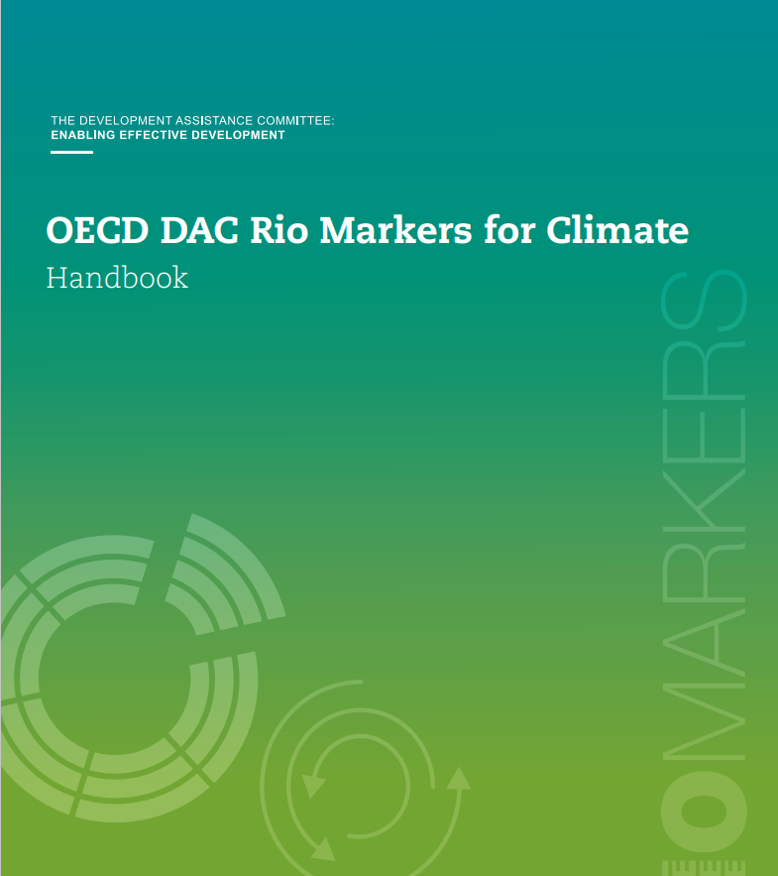
The list in the Handbook with examples of how different categories of activities are scored against the Rio climate markers (page 11-32) is useful when assessing activities. The list entails activities that are scored for different categories and in most cases it is possible to find an example similar to a particular project that it assessed
10. Rio markers are applied at the commitment stage, based on the project's original intention. For multi-year projects, the initially assigned markers should be maintained throughout reporting. However, if a project evolves to incorporate, for example, climate objectives later in its life cycle, adjustments to the Rio markers are possible to reflect these changes.
11. Projects are scored based on their stated purpose. In practice, Rio marker assessments are conducted by reviewing a project's objectives, context, and expected outcomes and outputs. In other words, the methodology follows a "purpose-based" approach and is applied at the start of the project (ex-ante) as set out in the OECD Rio Markers Handbook.
12. Assessments should be based on the information provided in the project documents. It is therefore important that the Rio markers are clearly justified in the project documentation budget annex. If information is insufficient—for example, if the climate objective cannot be clearly justified—the Rio marker score should be marked accordingly as “Not targeted (0).

Frequently Asked Questions
13. How to mark core contribution to multilateral organizations??
Earmarked contributions to specific projects, programmes or Trust Funds managed by multilateral organisations (the so-called multi-bi projects) are treated in the same way as bilateral projects.
The Rio markers, however, do not apply to true core contributions to multilateral organisations. If the multilateral organizations have a target for climate spending (most MDBs have such targets), Denmark uses these for assessing the climate content of the Finance Bill appropriation to be registered in “Finanslovsportalen”. For the later reporting of the climate content of these contribution to EU and UNFCCC, Denmark uses the so-called imputed shares that OECD-DAC calculates for relevant multilateral organisations every year based on the organisation reporting to OECD-DAC. For organisations that do not have climate spending targets or report on their climate spending to OECD-DAC, it is recommended to review the organization’s strategic plan and results framework and apply the standard policy marker methodology to conduct the assessment. If information is insufficient to clearly justify a marking, the score should be “Not targeted (0).
14. How to assess the climate finance contribution of SPA-agreement, CISU, FFU and similar framework arrangements that leads to multiple projects?
In these special cases, the Danish approach is to ask the relevant partner organisations or administrators to report back to the Ministry of Foreign Affairs on the climate relevant content of the specific commitments made during the year based on funds from the framework arrangement. It is recommended to the organisations / administrators that they use the Rio marker methodology to prepare these reports.
15. How do we assess contributions to Impact Fund Denmark (IFDK)?
[placeholder]
16. What if a large programme consists of different thematic elements or projects, some of which would qualify to be marked as 1 or 2 under the Rio marker methodology, while the programme as a whole would not?
It is important to capture all green elements in Danish development cooperation to provide the most accurate picture of total green development finance. If a programme contains different projects where some have clear green elements that are not explicitly reflected in its overall objective of the programme, a more granular approach should be applied, allowing scoring at the individual project level (“engagement” in PMI). In such cases, the average percentage of the individually scored projects should be used to determine the programme’s overall score. See the example below of a programme consisting of multiple projects.
Programme
Projects | Marker | Score | Justification | Budget | Climate share
Solar panel installation | Mitigation | 2 | Directly reduces greenhouse gas emissions. | 100 | 100
Community education with a climate focus | Adaptation | 1 | Raises awareness but is not the primary focus. | 50 | 25
Road construction | Mitigation | 0 | Does not target climate objectives. | 200 | 0
Total adaptation |  |  |  |  | 25 (7%)
Total mitigation |  |  |  |  | 100 (28%)
Total |  |  |  | 350 | 125 (35%)

This assessment should be done in the relevant budget annex on Rio Markers of the programme document and may result in a percentage on the appropriation cover note for programme documents that differs from the standard 0, 50% or 100% as illustrated below:
17. How to calculate the climate finance share when both climate adaptation and mitigation are scored 1 or 2:
Rio marker matrix table showing the “Type of Support” (Italic text) resulting from all Rio marker combinations, and the subsequent climate finance coefficient percentage. The total amount of climate finance reported will never exceed 100% of the project’s budget.
Rio markers scores | Mitigation “0” | Mitigation “1” | Mitigation “2”
Adaptation “0” | Not relevant: 0% of budget | Mitigation: 50% of budget | Mitigation: 100% of budget
Adaptation “1” | Adaptation: 50% of budget | Cross-cutting: 50% of budget | Mitigation: 100% of budget
Adaptation “2” | Adaptation: 100% of budget | Adaptation: 100% of budget | Cross-cutting: 100% of budget

Priorities for Danish Development Cooperation 2026. https://um.dk/en/danida/strategies-and-priorities/government-priorities-danish-development-assistance
UN Convention on Biological Diversity (UNCBD) and UN Convention to Combat Desertification
UN Framework Convention on Climate Change (UNFCCC)

