[Insert title of programme/project]

Key results:  [Examples of key result planned to be achieved at the end of programme:]  -  -  -  Justification for support:  [Why is this support necessary and relevant, how does it relate to Danish and partner country priorities:]  -  -  -  Major risks and challenges:  [What are the main risks and challenges for this programme to achieve intended results and objectives, are mitigation measures possible to manage risks:]  -  -  - |  | File No.
 |  | Country
 |  | Responsible Unit
 |  | Sector
 |  | DKK mill. |  |  | 20xx | 20xx |  |  | 20xx |  | 20xx | 20xx |  | Tot.
 |  | Commitment
 |  | Projected ann. Disb.
 |  | Duration
 |  | Finance Act code.
 |  | Head of unit
 |  | Desk officer
 |  | Reviewed by CFO |  |  | NO / YES: Name of CFO
 |  | Relevant SDGs [Maximum 5 – highlight with grey]
 |  | 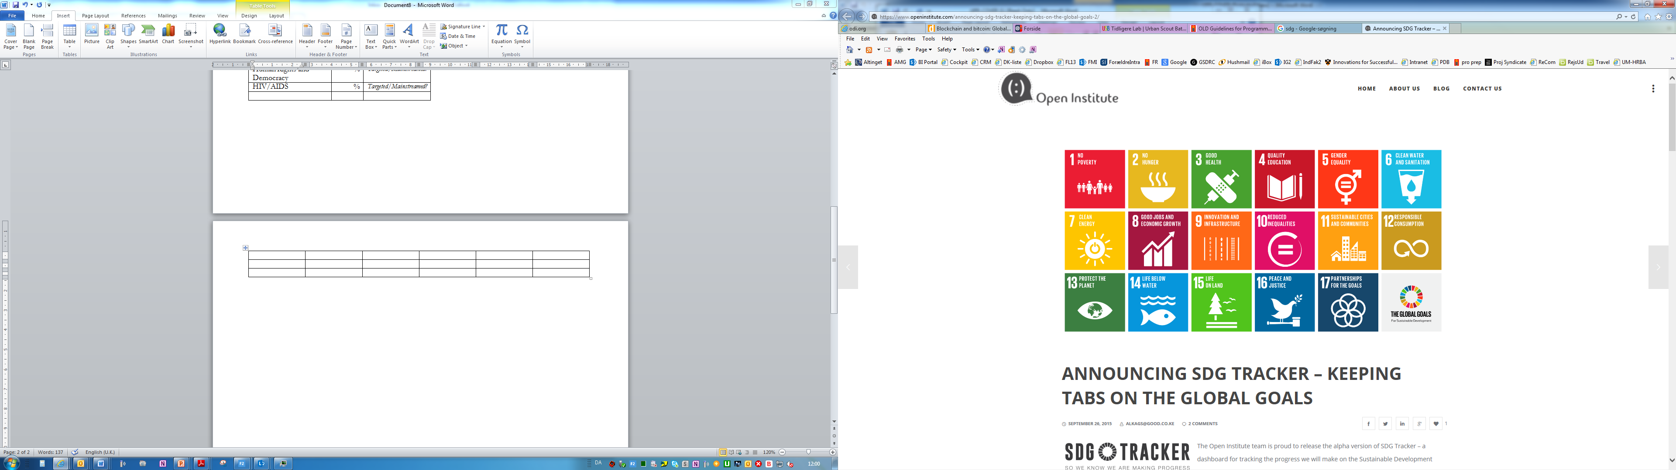  No Poverty | No  Hunger | Good Health, Wellbeing |  |  |  | Quality Education |  | Gender Equality |  |  | Clean Water, Sanitation
 |  | Affordable Clean Energy | Decent Jobs, Econ. Growth | Industry, Innovation, Infrastructure |  |  |  | Reduced Inequalities |  | Sustainable Cities, Communities |  |  | Responsible Consumption  & Production
 |  | Climate Action | Life below Water | Life on Land |  |  |  | Peace & Justice, strong Inst. |  | Partnerships for Goals
Strategic objectives:
[Text]
Thematic objective 1: [text]
Engagement | Partner |  |  |  |  |  | Total thematic budget: [mill.]
[Title of engagement 1] |  |  |  |  |  |  | [Budget engagement 1]
[Title of engagement 2] |  |  |  |  |  |  | [Budget engagement 2]
[Title of engagement 3] |  |  |  |  |  |  | [Budget engagement 3]
[Title of engagement 4] |  |  |  |  |  |  | [Budget engagement 4]
Thematic objective 2: [text]

Engagement | Partner |  |  |  |  |  | Total thematic budget: [mill.]
[Title of engagement 1] |  |  |  |  |  |  | [Budget engagement 1]
[Title of engagement 2] |  |  |  |  |  |  | [Budget engagement 2]
[Title of engagement 3] |  |  |  |  |  |  | [Budget engagement 3]
[Title of engagement 4] |  |  |  |  |  |  | [Budget engagement 4]
Thematic objective 3: [text]

Engagement | Partner |  |  |  |  |  | Total thematic budget: [mill.]
[Title of engagement 1] |  |  |  |  |  |  | [Budget engagement 1]
[Title of engagement 2] |  |  |  |  |  |  | [Budget engagement 2]
[Title of engagement 3] |  |  |  |  |  |  | [Budget engagement 3]
[Title of engagement 4] |  |  |  |  |  |  | [Budget engagement 4]
 | Programme support |  |  |  |  |  | [Budget for Programme Support]
 | Total |  |  |  |  |  | [insert total budget]

